Meet Your New ISI Colleagues
— April 2019 NSO Participants —
Colorado Springs, CO

Doug Cherry –Contingent Campus Staff – Lindale, TX

Doug is married to Jana “Kiki” and will be serving with ISI’s Fort Worth, TX team. He has been serving overseas in past weeks, hence, his full bio is currently unavailable.

Amber Gilpin – Contingent Campus Staff – Thornton, CO

“I grew up in Colorado and love all things outdoorsy, especially if it involves hiking or s'mores. I studied Youth Ministry at Northwestern College (A small Christian college in the middle of nowhere Iowa. We don’t even have a Wal-Mart!). Because there weren’t mountains to climb, I found other ways to stay busy, including the Intercultural Club and a Study Abroad trip to Italy. Since graduating I’ve moved back home and am volunteering with ISI while I work as a life-guard and assistant swim coach.”
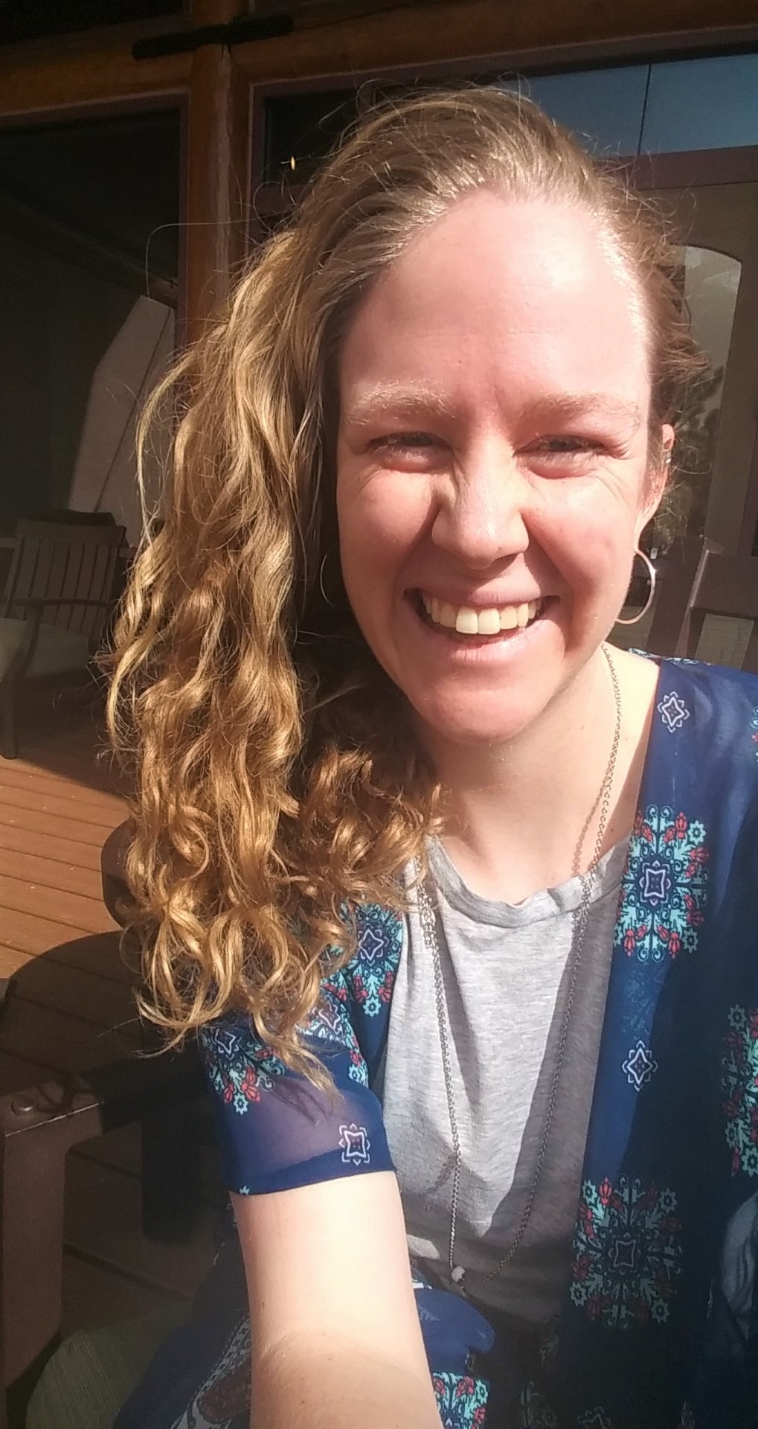

Judith Howard – Ministry Rep – Raleigh, NC

“My name is Judith Howard, and I live in Raleigh, NC. I have been married to my wonderful husband, Martin, for forty non-stop, adventurous years. We have two adopted daughters, Alyssa and Danielle, who are now adults and pursuing adventures of their own. In 2018, Alyssa married Michael Ellis, who has become a much-loved part of the family. Martin and I recently moved closer to NC State where we enjoy being closer to the students. After years of reaching out to international students, I remember the day I was captured by the thought that “I can fit ten people around my table, but I am only one person with one table…Lord, lead me to ways I can involve more people in this beautiful outreach.” When I was invited to be a guest at the ISI fall retreat in my region, I was struck with the answer to that prayer. I am so grateful for ISI’s training, relationships, and leadership…but most of all I’m grateful to become a member of the ISI family! (Fun fact about us: We’ve helped plant four churches…now my hope is to one day see an international student return to their native country and plant a church. Disciples making disciples.)”

Jeremy Kestle – Contingent Ministry Rep – Spokane, WA
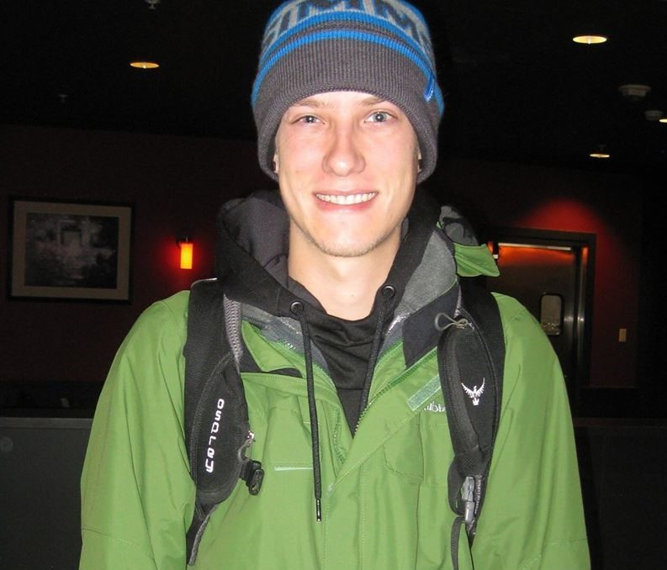
“God has put people from all over the world in my life from the beginning, including the Bosnian student who helped me accept Christ and the student from Uzbekistan with whom I first shared the Gospel. In 2014, I traveled to Nepal and felt the beauty of fully experiencing another culture. It solidified the idea that I wanted to always be involved with God’s global purpose, and I immediately began my journey in international student ministry while attending the University of Idaho. Now I am excited to continue that work with ISI.”

Emily Koester – Contingent Campus Staff – Modesto, CA

“I’m excited to serve the Lord through international student ministry. God has been developing my heart for the nations for a few years now, drawing me cross-culturally in a few different ways. From living as an au-pair in Australia for seven months to serving in the country of Slovenia for three months, I feel that He’s poured out an abundance of experiences with people of different cultures, and I’m so thankful. Most recently, I attended a Missionary Training School through Global Frontier Missions. This experience impressed more deeply the importance of welcoming foreigners who are coming to America as students, refugees, or immigrants. I was able to develop friendships with international students and loved having the opportunity to share Christ with them and discuss spiritual things. I’m thrilled to be on the ISI team, and I’m looking forward to what God will do in Sacramento, and the world!”

Greg Roth – Contingent Ministry Rep – Freemont, CA
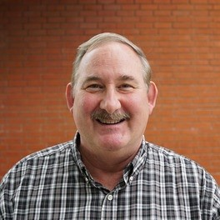
Greg Roth has had a lifelong love for people of other cultures. He worked on staff with Navigators’ campus ministries in Ghana, West Africa before returning to the United States and pursuing a masters and doctorate in intercultural studies at Fuller Seminary. Greg has served Presbyterian congregations as pastor of outreach for over 30 years and currently works with Centerville Presbyterian. He has also worked as a volunteer feeding the homeless and building affordable housing for homeless families through Habitat for Humanity. Greg will be joining the ISI team serving at the University of California in Davis, CA.

