International Students, Inc. – NC 2019
Recruiting Volunteers

Introduction
- Make it normal – Normalizing ISM aka Creating Culture

- Make it theirs – Expectations, empowerment and ownership

- Build it tough – Resilience through redundancy

- Build it to grow – Perpetuation, maturity and multiplication

Team Building
- Build community
- Distributed workload
- Kingdom community

Resources
- Everyinternational.com
- Perspectives.org

Recruiting
- Prayer
- Functional ministry
  - Visibility
  - Observation options
  - Bring someone
  - Find a niche
  - Indirect ministry
- Encourage stories

- Inreach – more formal vectors
  - buy-in from leadership
  - Adult Sunday School classes
  - Ministry Fairs
  - Church-wide events and ministries
  - Informal lunches
  - Stories spread
- Perspectives
- Church conferences
- Guest speaker
- Beyond ISM

On-ramping
- Observation
- Application
- Guidelines and policies
- Training
- Mentoring

INTRODUCTION
AND
OVERVIEW

SaturationSoCal@isionline.org

The Scenario
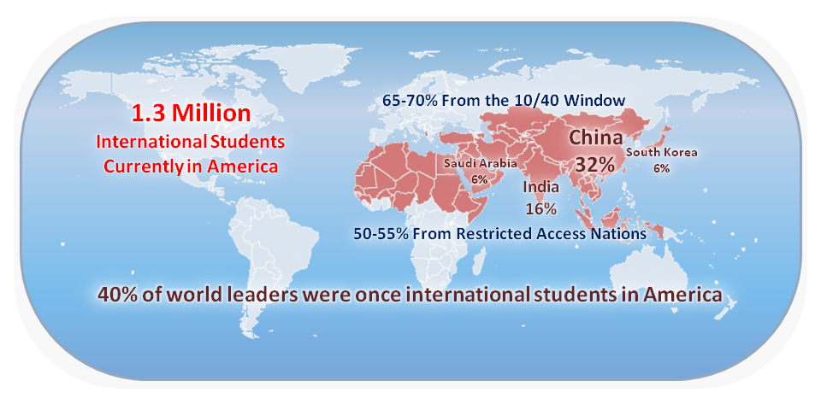
International Student Ministry (ISM) is one of the most strategic avenues of missional engagement available to the Church.

- Between 1.3 to 1.8 million international students are presently in America (2019).
- 65-70% of international students come from 10/40 Window nations.
- 50-60% of international students come from Restricted Access Nations.
- 60% of international students come from China, India, Saudi Arabia, and South Korea.
- 40% of world leaders were once international students in America.

The nations have come to us. Even more so, the Southern California area represents an incredible opportunity for outreach and evangelism, with an unparalleled potential for global Kingdom advancement.
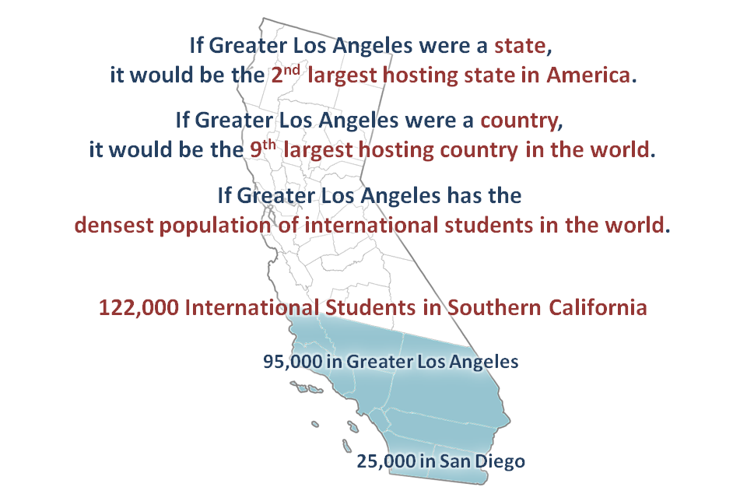

- There are an estimated 122,000 international students in Southern California.
  - Greater Los Angeles hosts just under 95,000 international students.
  - The San Diego region hosts another 25,000 or so international students.
- If Greater Los Angeles were a state, it would be the 2nd largest hosting state for international students in America.
- If Greater Los Angeles were a country, it would be the 9th largest hosting country in the world, sitting between Japan and the Netherlands.
- Greater Los Angeles has the densest population of international students in the world.

However, it is also a harvest field that is in desperate need of workers.
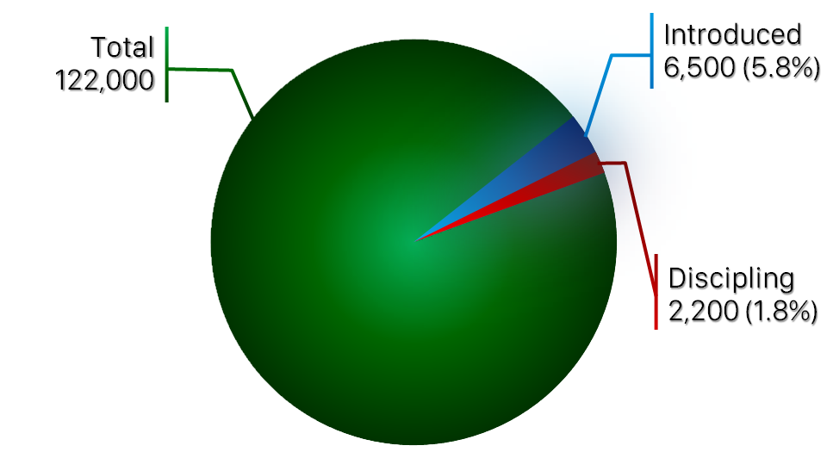

- There are currently 17 International Students, Inc. staff and 11 Ministry Representatives operating in this area, with around 800 volunteers actively engaged with students.
- Approximately 6,500 students have been introduced to the ministry of International Students Inc., of which an estimated 2,200 students are engaged in relationships that are being actively cultivating by International Students, Inc. staff and volunteers.
- This works out to approximately 5.8% of students in this area having been introduced to International Students Inc., with only around 1.8% of international students being meaningfully engaged with the Gospel.

There is much to be done, and help is needed. The fields are ripe, but the workers are few. Will your church rise to join the harvest?

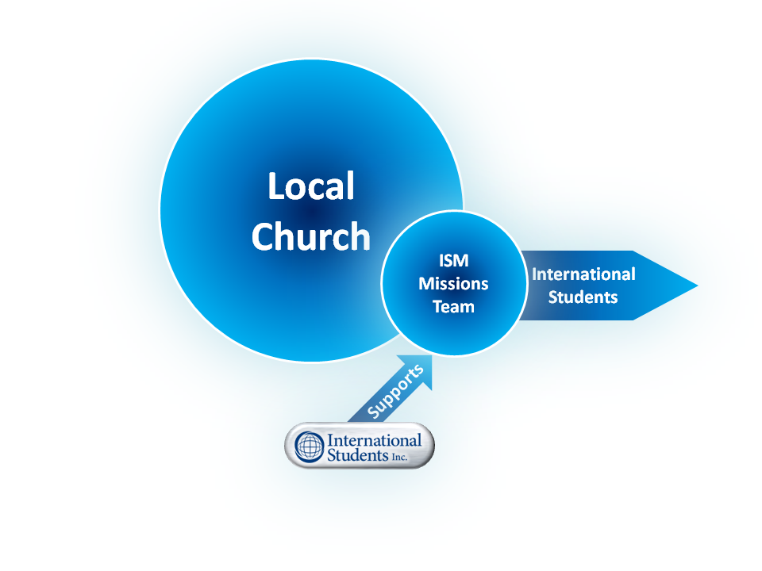
The Strategy

Saturation SoCal is an ISM Mobilization Initiative by International Students, Inc. that proposes to partner with local churches across Southern California to raise up and establish church-based missions teams, with a view to saturate the region with ISM efforts.
- Saturation SoCal aims to assist local churches in establishing localized, self governing, self perpetuating, self financed (by the local church to which they belong) teams under the oversight of the local church.
- Each medium-to-long term team will operate out of the local church, under the aegis of its leadership, and should remain very much a part of their establishing church to be an extension of their ministry.
- International Students, Inc. can provide training and specialist resources in an advisory, consultation or ministry partnership capacity.

The Structure
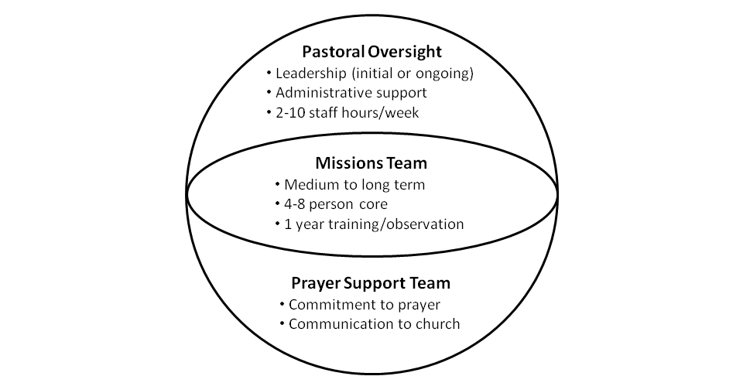

A fully-realized ISM Missions Team would consist of three key parts:
- Pastoral Oversight
  - One or more members of the pastoral staff, interns or dedicated lay leaders to shepherd the team, at least in the initial stages. This can become an ongoing leadership or advisory role, as needed.
  - Initial provision of administrative support (booking facilities, facilitating communication, scheduling meetings, etc.).
  - As needed, between 2-10 hours of staff time per week
  - Ongoing general oversight and accountability.
- Mission Team
  - Medium to long term commitment required
  - At least, but not limited to, 4-8 individuals to form the core team
  - Others are encouraged to serve together as part of the wider team.
  - Mission Team members should be members of good standing within their local church, and possess the qualities preferred in outreach and cross-cultural ministry contexts.
  - The Mission Team will undergo a one-year training period, as detailed in the following section.
- Prayer Support Team
  - Each Mission Team member will recruit at least 1-2 prayer warriors to be part of the Prayer Support Team.
  - The Prayer Support Team will be dedicated to praying for the Mission Team, standing as their prayer warriors, remaining in regular contact, and encouraging them in their ministry.
  - The Prayer Support Team meets regularly, either in person, online, or via conference call, to pray for the Missions Team.
  - The Prayer Support Team also acts as the Mission Team’s liaison with the congregation, periodically updating the church regarding the ongoing ministry of the team.

The Specifics
Generally, establishing a church-based missions team in effective ministry among internationals students will consist of three phases, here called: Link, Learn and Launch.

Link – Encountering the Opportunity
- Members of the congregation have to be introduced to ISM and the opportunity to reach the nations, which the Lord has brought to our doorsteps. This can happen in multiple ways, including, but not limited to:
  - Publicity, encouragement and teaching from church leadership, which is likely the most effective approach
  - Missions spotlight or informational session by an ISM missionary or mobilizer from International Students, Inc. or other ISM organization
  - Attending an ISM conference or event like the InterGen Global Forum, an ACMI Conference, or International Students, Inc. Conference
  - Word of mouth from those already involved in an ISM ministry.
- Exact application and vetting processes will vary by church, but there should be one in place. International students are often young, impressionable and can be considered a vulnerable population. Furthermore, continued access to campuses can be tenuous given the current attitudes toward Christians in the public square. All efforts should be made to ensure that the Mission Team Members are of appropriate and Christ-like character.

Learn – Educating the Interested
- It is recommended that the Mission Team go through a one-year training, observation and team-bonding period, which should include, but not be limited to, the following:
  - Taking a Perspectives class at a minimum of certificate level (www.perspectives.org)
  - Going through the free EveryInternational training course (www.everyinternational.com)
  - Observing and serving alongside a pre-existing ISM group. This informal “internship” will provide valuable experience and provide experiential models that will assist in the formation of the Mission Team’s eventual ministry model
  - Additional, specific training for the team’s intended context, including M:28, the highly reproducible inductive Bible study system that was specifically created for international students by International Students, Inc.
- Other ISM events and conferences can also be considered and encouraged, but the four elements above should be considered mandatory.
- During this time, the Team is encouraged to explore possible venues and avenues for their ministry. Potential campuses, student communities and resources should be investigated and considered. Some teams might consider working with ISM practitioners to begin building trust and working relationships with the International Student Offices of nearby campuses.
- In addition, Missions Teams are encouraged to meet together regularly to facilitate bonding and community building beyond “events.” The Team will be working closely with each other as a small community, and a genuine love and concern for one another is essential. Whether it be having lunch after Sunday service or hanging out together over the weekend, the Team should grow closer in fellowship and community throughout the year.

Launch – Establishing the Ministry
- At the end of the one-year training, observation and team bonding period, the Mission Team will meet to determine the distinctive form of their ministry.
- With prayerful consideration, the team will draw from their year of experience and training, as well as the gifts, talents, skills, resources, and strengths, along with appropriate input and advice from pastoral leadership and ISM practitioners, to determine the context, methodology and structure for their ministry.
- A team prayer retreat is a good option for the beginning of this phase and is highly recommended.
- Once the potential pattern of ministry is determined, the Team will launch the ministry, with ongoing evaluation and adaptation.
- As this occurs, the Team should keep a multiplication mindset in mind, and be considering the perpetuation of the ministry and the passing on of the mantle to the next generation of leaders.

The Strategic Blessings
There are numerous benefits for a church that involves itself in this strategic harvest field beyond those gleaned from the Mission Team’s direct efforts to bring the Gospel to the nations. Here are eight:
- Normalizing cross-cultural engagement – As international students become part of the spiritual and social fabric of the church, cross-cultural awareness among the congregation is increased. This, in turn, lessens the fear of the “other” and normalizes cross-cultural engagement, making it much less daunting and thereby, emboldening the congregation to be more impactful in Gospel proclamation and advancement within the local community and beyond.
- Increased readiness – International students often come to the Bible with fresh eyes and ask questions most in the West assume or never think (or want) to ask. This prompts and prepares the congregation to be more ready to stand as witnesses and give an account for “the hope we have” as they seek to explain what we believe as well as see how people of different cultures and backgrounds interpret what they see in God's Word.
- Living out the Commission – With the nations of the world at our very own doorstep (and in our backyards, and in our kitchens, and at our dining tables…), this is an opportunity for the congregation to actively and dynamically live out the Biblical mandate to make disciples of all nations, growing in compassion, empathy and understanding with those who seem very different from “us.”
- Experiencing God’s heart for the nations – International students who have come to follow Christ often bring with them a zeal, energy and eagerness that challenges any notion of stagnation. Encountering what God is doing in the lives of international students, and perhaps even meeting the students themselves, could potentially renew and ignite a heart for missional engagement among the congregation.
- Pre-mission preparation and cultural encounters – International students come from all over the world, many even hail from unreached people groups. This provides an incredible opportunity for those preparing to go on the field to personally meet members of specific people groups before they depart for cultural acclimatization, language learning, or more.
- Raising up and equipping the next generation – Parents are given the opportunity to show their children, youth and college students a wider world beyond their regular social circles, allowing them to learn to better navigate this increasingly connected and globalized world. They will gain cross-cultural competence and other valuable skills that will help them become even more effective conduits of the Gospel. Whether going across the street or across the seas, they will learn to better communicate the Good News through all of life. Furthermore, having the advance of the Gospel of the Kingdom among the nations demonstrated to them on a regular basis provides them with unparalleled grounding and confidence in the reality and efficacy of the Biblical worldview. Witnessing firsthand God at work among the nations will make them better witnesses for Him.
- A role for every season – Students miss their often multigenerational families, and thus, ISM has a role for people in every season of life, from children to seniors, to be participants in effective and impactful ministry. The Lord can use the collected wisdom of a senior or the unfiltered directness of a child to speak powerfully into the lives of students from across the world.
- A deeper appreciation of Biblical context – Many students come from places and cultures that share similar worldviews and cultures as the people in the Biblical narrative. They bring the Biblical narrative to life, demonstrating the cultural context of the Biblical narrative and deepening our understanding of what the Gospel means to the world.

