Lead to Win!!

Winning is always about God’s sovereign choices, prayer, and excellent leadership! And a key part of leadership is a strategic plan! A strategic plan is all about choices… and playing to win!

Strategic Choice Cascade

A.G. Lafley and Roger L. Martin’s 2013 book Playing To Win: How Strategy Really Works is a great read that is deceptively simple and filled with behind-the-scene illustrations from the world of P&G (Procter & Gamble) where Lafley was able to conceptualize and refine the model as CEO of one of the most successful companies in recent history. In order to devise one’s strategy, the authors simplified thinking into the quest to answer five interrelated questions:

- What is your winning aspiration? The purpose of your enterprise, its motivating aspiration.
- Where will you play? A playing field where you can achieve that aspiration.
- How will you win? The way you will win on the chosen playing field.
- What capabilities must be in place? The set and configuration of capabilities required to win in the chosen way.
- What management systems are required? The systems and measures that enable the capabilities and support the choices.
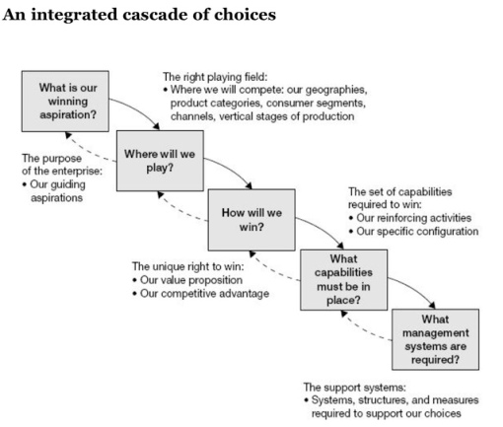
An interesting point is to look at the arrows. Notice they do not only flow down like a waterfall from left to right but also flow back “upstream.” This illustrates the concept that strategy is both iterative and non-linear. In reality, one needs to revisit the answers made to the earlier choices as more clarity is obtained by answering subsequent questions. For example, if one’s organization doesn’t possess the requisite capabilities (determined in choice 4), one would need to revisit prior choices in order to formulate a more implementable or realistic set of strategic choices for your current thinking downstream.

Finally, the authors also point out that these choices (all 5 boxes), as applied to the larger organizational level, can then be “cascaded” down to the next level… i.e., the group or ministry unit where the leaders there take reference from the parent but work out the answers to their own strategy cascade choices within those boundaries set. This allows the whole organization to align their strategic choices and to better support the overall strategy to formulate coherent and mutually reinforcing activities.

The cascading strategy answers 5 questions that force one to make complicated choices:

- What is your organization’s purpose, or “winning aspiration”?
- What are your target markets/audiences?
- How does one succeed with each of those markets/audiences?
- What capabilities does your organization need in order to win?
- How should you manage your organization in order to win?

Once choices are made to answer these questions, a task list is created where accountable actions are determined that follow from the strategy chosen.

See the following example of what that might look like in a local ISI ministry…

