Trends and Issues Impacting ISM and Our Strategic
Planning for Academic Year 2019-2020

Overview
- USA college student demographics will remain flat for the next decade, meaning…
  - Colleges will be under increasing financial pressures because of dropping enrollments
  - Colleges will be fighting for students, especially international students
    - Strategic opportunity for ISI ministries who can work with their foreign student office to provide the BEST experience possible for students (who will tell their friends to come to that university) through community involvement in trips and events and weekly home groups for students
    - Strategic opportunity for ISI ministries who have a good returnee network and who can use that network to recruit for their local university; if you are bringing full tuition-paying students to the university, the administration will be glad to work with you [with the world system, it’s always all about the money]
  - Campus ministries will be fighting for Christian leaders for their ministries (more so than usual), and some of the campus ministries may have weak leadership for a time
  - Tuition increases alone cannot support the financial needs of a university; small private and Christian colleges are closing at the rate on one per month
- Nationalism and populism world-wide will continue and intensify (e.g., Brexit, India, EU, etc.)
  - Leading to more self-imposed isolation among int’l student ethnic groups on campus
    - Strategic opportunity for ISI ministries who can start separate ethnic ministries (Indian, Chinese, African, etc., or separate home groups) instead of just one ICF
    - Strategic opportunity for ISI ethnic specialist campus ministers (as we have done in the past with Chinese student or scholar ministries)
  - Ethnic-focused int’l student clubs will become more important
    - Partnerships with these clubs may become an important entrée to meeting students
    - What these clubs specifically need may become a stimulus for ISM program development on your campus (e.g., instead of a general conversational English program for students from any ethnic background)
- We read that Christianity is shrinking, but that is not true – the number of evangelicals has remained VERY steady for decades; what is happening is that the culture is pulling away from evangelicals and creating a gulf between evangelicals and other Christians (illustration from Ed Stetzer’s Christians in the Age of Outrage)

- Baby Boomers are retiring in record numbers, they have money-skills-networks, they have no long-term plan for retirement, and they still want to change the world in the next ten years
  - Incredible volunteer army available for those who know how to challenge them
    - Strategic opportunity for ISI ministries who know how to connect through churches with these folks, who can get them into Perspectives on the World Christian Movement classes, and who would create free retirement seminars with a Christian retirement specialist and put these seminars on in churches to recruit volunteers and potential staff
  - Boomers have leadership capabilities but may clash with millennials over work-ethic issues
- Funding for millennials from millennials will continue to be an issue for new staff
  - Team accountability for new staff raising funds will become the new standard
  - If you are a team leader (or ever hope to be one), you must read Scott Morton’s book Blind Spots and Steve Shadrach’s The God Ask
- Listening to God in prayer is the “new” strategic planning mode—after all, it is HIS ministry!
  - This doesn’t happen in a half-day planning meeting; it takes days of being quiet before the Lord in a retreat setting and learning to listen to the still small voice of the Holy Spirit (Didn’t Jesus set the example for us?)
  - We have to learn interdependence as a team… as the Spirit gives different pieces of an overall plan to different people on the team (so we learn to trust and depend on each other)
- Success on campus is all about prayer… it always has been… and always will be
  - Leaders of miraculous discipleship movements spend six hours per day in prayer; do we want to lead discipleship movements? [The answer for most U.S. leaders is “No.”]
  - Individual prayer, ministry team prayer, volunteer’s prayer, prayer team prayer, warfare prayer, donor’s prayer
  - Strategic leadership by campus leaders is critical and is communication with the prayers (BOTH new needs AND answers)

China (also see the following docs for additional info on China)

- Current crack down on Christians/Muslims is the worst it has been since the Cultural Revolution
- Chinese informants/spy’s on U.S. campuses are now worse than 30 years ago (when one in four Chinese students were reporting back to the government); money/status is the incentive; we have to be very careful of identifying publicly followers of Jesus in our open meetings
- Moderate persecution and refocus on house churches (from large or megachurches) by the church in China should lead to the total number of real Christians in China doubling in the next decade and China becoming the country with the most Christians in the world (it may be that already)
- Communication with Chinese returnees continues to be a VERY difficult issue and it changes regularly (encourage students to use yahoo.com email while in the U.S. or their university email address; and to download Signal, WhatsApp, Telegraph, Proton Mail, and Hushmail while here)

India (also see the following docs for additional info on India)

- Prime Minister Modi won the election significantly; watch for increased persecution of Christians
- 50% of India’s population is under age 35; they cannot absorb all of their growing workforce
- While more rapes are being reported, women are not necessarily safer in India today because the conviction rate has not changed for perpetrators
- India’s 400 million millennials are a driving force behind the mobile economic revolution and will impact consumer demand for autos, telecom, finance and real estate in the years to come
Challenges Christians Are Facing in China, India, and the Middle East
(April 2019)
China
- There are an estimated 200 to 300 million cameras operational in China with facial recognition software capabilities. Supercomputers are matching voice recognition and facial recognition profiles with people’s social credit score to have a complete dossier and political rating on every person in China.
- Spring 2018 more than 100 missionaries were forced to leave western China and in October 2018 more than 200 were forced to leave central China. People assume there will be a purge in eastern China this spring sometime.
- In the city of Kashgar (northwest China) there are gated ID checkpoints every 100 yards on the main streets where facial recognition cameras check ID cards. This is a test to see if it is practical in other cities.
- In all 3-Self churches (registered legal churches), video cameras record attendance for the government of everyone who attends. No one under age 18 may attend, and it is illegal to teach the Bible in your home to children of any age.
- Most house churches (unregistered illegal churches) can no longer meet in groups over 30 and have broken up into house churches with less than 15 people in each.
- The government is now offering up to a $1,500 (USD) bounty for information on illegal house churches.
- The social credit score system to politically rate and evaluate every Chinese citizen will be fully functional in 2020. (Already is in some cities… and the crime rate has dropped!)
- A majority of Chinese international students and returnees are not aware yet of the realities listed above!

India
- U.S. Commission on Int’l Religious Freedom now ranks India’s persecution severity as “Tier 2” along with Iraq and Afghanistan. In just seven years, Open Doors World Watch List has moved India up from number 31 to number 10 (just behind Iran) in persecution severity.
- Since the Modi government came to power in 2014, attacks on Christians have increased dramatically because Hindu nationalists see no consequences for their violence and attacks.
- Hindu nationalists seek to rid India and Muslims and Christians—seeing them as alien to the nation. Anyone who converts to Christianity faces relentless persecution to “return” to Hinduism from family, neighbors, and the community.
- The Religious Liberty Commission of the Evangelical Fellowship of India confirmed 18 separate attacks on Christians in the weeks leading up to Christmas.
- The Alliance Defending Freedom reported 60 separate attacks in five southern states in a nine-month period in 2018.
- As the use of social media is exploding in India this year, the proliferation of anti-Christian fake news is increasing… especially as national elections are in process for the next 6 weeks.

Middle East
- In November 2018 the bodies of seven Coptic Christian pilgrims were found in south of Cairo; the Islamic State (IS) took credit. IS massacred 28 pilgrims near there in 2017.
- In December 2018, the Archbishop of Canterbury Justin Welby warned that Christians in the Middle East face “imminent extinction.”
- Most Americans are surprised this is still taking place because it is not in the news daily.

15 Trends for Leaders to Expect in 2019, Including a Surprise about Email

Dan Busby, President, ECFA

- The digital revolt will ramp up. It is a seeming contradiction! Over 50% of people want you to communicate with them by email (direct mail is the next popular channel, coming in at only 20%).1 And 38% would like emails to come even more frequently.2 But 59% of people do not want to give you their email address.3 Email is the original social network, but users now expect a consent-based use of their data. The second email they receive without their consent is considered spam.

- There will be more staff meetings. The “Rockefeller Habit #3: Meeting Rhythm” is getting traction—and it is about time.4 The daily huddle, the weekly meeting, the monthly management meeting, and the quarterly and annual planning meetings should be priorities—period! Otherwise, you are leaving productivity—an outcome of good stewardship—on the table.

- Communicating via mobile devices will continue its meteoric rise. 47% of all email is opened on a mobile device—and this percentage is rising. Folks will Google your website on their mobile device, so your site needs to be mobile-friendly. By 2020, approximately 80% of the content consumed will be video, and it will be primarily viewed on mobile devices.

- The economy will probably slow down. Up until the last few months, the U.S. stock market had a strong, 10-year run since the 2007 recession. Now, with some signs of the world economy cooling, political instability, and massive debt burdens on governments, organizations, and individuals, a slower economy in 2019 is likely. Good stewardship will require a proper focus on debt levels and cash reserves.

- Hiring new or replacement staff will be done with more care. “The cost of a bad hire is 15x his or her annual salary, so it’s important to get the recruiting and selection process right.”5 When the economy struggles or declines, the importance of hiring quality people is multiplied.

- For many ministries, it is either grow or die or become trapped in malaise. Many smaller ministries struggle to move beyond the status quo. They are caught in the “not big enough” syndrome. I often call it the $2—$3 million annual revenue glass ceiling.

- The office will continue to empty out. Working at home has been increasing, but it may reach the “tipping point”6 in 2019. This will give people more quality time to work without the

1 Adobe Email Survey 2018 US
2 Constant Contact: 10 Eye-Opening Email Marketing Stats You Need to Know
3 digitalsummit/Dallas, December 4-5, 2018
4 Mastering the Rockefeller Habits: What You Must Do to Increase the Value of Your Growing Firm, Verne Harnish
5 According to Topgrading, as referenced in Scaling Up by Verne Harnish.
6 “The moment of critical mass, the threshold, the boiling point,” as defined by Malcolm Gladwell in The Tipping Point: How Little Things Can Make a Big Difference.

wear and tear of the daily commute to the office. The price we will pay is loss of community and weakening of the ministry’s culture. And, “culture eats strategy for breakfast.”7

- More ministries will embrace the importance of excellence in governance. The partnership between the board and the organization’s top leader, care in choosing board members, even more care in choosing the board chair, and the commitment to prayer and discernment are just a few of the 2019 emphases for ministries. And yes, I would say this even if ECFA were not conducting 10 Forums on Excellence in Governance in 2019. Stay informed about the Forums at ECFA.org/GovernanceForums.

- Boards are increasingly sensing the importance of self-assessment. Peter Drucker said “Self-assessment is the first action requirement of leadership: the constant re-sharpening, refocusing, never really being satisfied.”8 And the same is true of governing boards. New online self-assessment tools are coming from ECFA in 2019, making board self-assessment easier than ever: ChurchBoardScore and NonprofitBoardScore.

- Succession planning will finally get its due. In 2019, boards will be even more faithful in addressing both emergency succession issues and long-term succession planning. They will pray for protection yet establish appropriate policies—and thus are prepared for a future transition. See ECFA’s Succession Planning toolbox online at ECFA.org.

- Integrity in raising financial support will increase. Givers see right through high pressure tactics and gimmicks—and they will increasingly reject them. Clear communication with givers about ministry impact will be important to raise needed funds.

- Givers will increasingly insist that their gifts for restricted purposes be honored. Raising money for A and spending it for B has always been a no-no. And, ministries that operate in that gray area—confusing givers as to whether their gifts are restricted or not—will pay the high price of lost support.

- The fixation on overhead percentages will continue to dissipate. Too often the question is asked: “What is the ministry’s overhead percentage?” Instead, the question should be: “What is the ministry’s impact?” Overhead percentages are often WAGs (wild ankle guesses). Excessive concern about overhead is unwise.

- Out-of-town travel will be scaled back. Ministries will frequently trade getting on airplanes for cutting-edge technology. Travel is expensive and time-consuming. More board meetings will be held virtually at the cost of collegiality. More staff members will do their life-long learning online and skip flying to conferences. Sometimes the best trip is not to travel at all.

- Hearing from God will trump strategic planning. Ministries are becoming more receptive to hearing from the Holy Spirit first and then using strategic planning to carry out God’s plan. But, first, we must master the discipline of stillness, lower the RPMs, and be aware of the gentle promptings of the Holy Spirit.

7 This quote is often attributed to Peter Drucker and echoed by William Vanderbloemen in Culture Wins: the Roadmap to an Irresistible Workplace.
8 Peter F. Drucker, Frances Hesselbein, and Joan Snyder Kuhl, Peter Drucker’s Five Most Important Questions: Enduring Wisdom for Today’s Leaders.

Trends and Issues Conference Call with ISI Staff February 15, 2018

Introduction
- The world is changing fast and the rate of change will only get faster; but not all things change at the same rate of change; how do you keep up… you cannot (unless small world)
- We learn how to filter out the noise of change that is not helping to us do better/more; but God’s Word is so critical to keeping perspective on what is important and what is not!
- Following Jesus in what he has for me to do today (read: serious significant prayer each morning) is a great strategy for keeping up with what Jesus thinks I will need that day; isn’t that what Jesus taught and modeled for us?!
- We do have to keep reading and being open to learning new things—setting aside time each week to do so (schedule reading time on your calendar like an appointment)—because that is part of being faithful to what Jesus called us to do as missionaries!
- Moving from a unipolar world to a multi-polar world (Fred Markert’s talk at NC); Christianity grows fastest and best in a unipolar world… multipolar worlds lead to wars
- BRICS – Brazil, Russia, India, China, South Africa (up and comers)—something to watch as the world stage is changing… there are a number of hungry-for-power leaders out there
- We read that Christianity is shrinking in the U.S.—not true! Harvard and Indiana U study by sociologists found mainline groups shrinking but independent Bible believing groups are growing like crazy, so Christianity is growing in the U.S.

Nationalization of countries and the changing attitudes of students coming from there
- Brexit, China (militarization of man-made islands in the South China Sea to extend Chinese power over neighbors), Putin (aggression in Ukraine and annexation of the area called Crimea, also in Syria), and Trump election in the U.S. are all examples
- On the domestic front, Gideon Rachman [a Financial Times journalist and author of Easternization: Asia’s Rise and America’s Decline] writes, this global rebalancing is marked by a trend toward heightened nationalism under strongman leaders. Examples include Indian prime minister Narendra Modi‘s Hindu nationalism, Xi Jinping’s “Chinese Dream,” Vladimir Putin’s resurgent Russia, and, yes, “America First” under Donald Trump. Rachman says “expanding economies feed growing military budgets, enabling nations that have chafed under Western global leadership to correct what they view as the wrongs of history. The decades-long quest for interdependence that characterized the post-World War II era is now giving way to the politics of raw power.” [US National security Chief said “World war is more likely than most people realize” yesterday in a congressional hearing that was televised.]
- “The question of whether and how the Americans should resist Chinese ambitions in the Asia-Pacific region is,” according to Rachman, “likely to be the most critical issue in international relations in the coming decades, since it pits the world’s two most powerful nations against each other.” [China sees the primary obstacle to their taking their rightful place as the middle kingdom—between heaven and earth—being the United States.]
- The changes aren’t just taking place “out there”; the forces redrawing the global landscape have profound influence domestically as well. What happens in Beijing or Shanghai does matter in Minneapolis and Chicago and Denver. [Dr. Brent Fulton]
- India kicked out 40,000 NGOs (Compassion among them) and many missionaries as the country became more focused on being Hindu nation with “no room for Christianity”

- How might this shift toward nationalism impact the local campus?
  - More students only hang out socially with members of their ethnic group
  - Less likely to buy into the multiculturalism marketed by campus deans
  - Not as interested in staying in the U.S. after graduation… so they can take their degree and go help the motherland
  - More available to being agents of their country [spying while here; more later]
  - Less open to relationships with Americans (students or community volunteers)
  - More argumentative and sensitive to perceived insults about their country
  - ???
- What do we do in light of these potential changes in student openness?
  - Prayer is the key; God opens the hearts of who he wills to work in; the Lord will show us who he wants us to work with
  - Focus on some of the ethnic groups which are not experiencing as much renewed nationalism and who do not have the support structures that Chinese/Indians have
  - Increasingly focus on student-led ministry where we serve in the background equipping and envisioning the student leaders without as much of an up-front role (so we as Americans are not an issue seen seeking to control what students do)
  - ???

China and Chinese Students
- After the last Communist Congress this past fall, Xi Jinping’s power now equals or exceeds Chairman Mao’s; he consolidated all police and military power under himself
- Aggressive attempt to limit foreign (primarily Western) influences/influencers access to China—2017 new NGO law and 2018 new religion law [friend training pastors in China now emphasizes the house-church model and limits the number to 8 before the group splits off a group] [Derrah believes the Lord is increasing the rate of expansion of Christianity in China by this move away from large church groups to house churches]
- China’s use of technology in people control is amazing…
  - Chinese students in U.S. universities getting a call from their parents not to believe something their professor said the previous day in class about China
  - Australian journalist gets call in hotel room 90 minutes after incident at bus stop
  - Australian professors censored about lecture material deemed critical of China by Chinese authorities or Australian book publishers pulling books about China
  - Online publishers forced to remove access to hundreds of articles available online that are critical of something in China—one caved then changed, another caved
- Use of CSSA (Chinese Student and Scholars Association) on campus plus the Confucian Study Centers (read $s given to the university by China) on campus to spy on Chinese students and to protest university actions considered contrary to China’s interests (e.g., letting the Dali Lama speak at a university in Southern California).
- WhatsApp was shut down in China; WeChat is government monitored
- Pay scales for high tech positions are now almost equal in China and the U.S., so many more Chinese students are returning home after study (mixed with the difficulty of getting H-1B visas in the U.S. now).
- Some Chinese student’s parents are spending $10K to $1 million paid to intermediaries to get their child in the Ivy League and the most prestigious U.S. universities
- China skipped credit cards and moved the populace from a cash-society to a smart-phone payment system (at the Zhengzhou Airport this past summer we could not buy food as they did not take cash in the food court! Only WeChat Pay or Alibaba Pay!)

- How might these trends in China and among Chinese students impact the local campus?
  - Students have more money and buy the services we used to provide for them when they first arrive here
  - Students travel at each of the breaks and are less interested in trips/activities we provide
  - Students are on a proscribed path to prosperity and success and don’t value what we offer to them—everything is evaluated in terms of progressing their career
  - Students have little time for other things than studies or activities provided by the campus Chinese groups or local Chinese churches
  - ???
- What do we do in light of these factors in Chinese student life?
  - Prayer again is the key; God opens the hearts of who he wills to work in; the Lord will show us who he wants us to work with and draw them to us
  - Because what happens on campus gets back to Chinese authorities, we may need to do more discipleship in one-on-one settings, and recognize that students who attend our events might be monitored and reported to Chinese authorities
  - Be careful of content you send on WeChat, it is monitored
  - ???

It is possible that 50% of colleges and universities will close/merge in the next 10 years
- NOT the large and prestigious institutions who have endowments
- Univ’s can’t raise tuition fast enough (parents/students already balking at tuition/debt)
- States pulling back public institution monies due to tight state government budgets
- Demographics: available new U.S. college student population will be flat for the next decade (will not be growing)—so much more focus on recruiting
- Schools who have grown dependent upon growing international student populations will suffer as the number of students applying will flatten out (not keep increasing); the crushing of Intensive English Programs last year with the rapid reduction of Saudi and Brazilian students is an example (UNT laid off 14 of its 20 intensive English instructors)
- Thunderbird School of Int’l Management (tops in nation) bought by Arizona State Univ
- Small Christian colleges closing in record numbers (Grace Bible College in Omaha, Southern Bible College in Alabama, and Moody Bible problems)
- Peter Drucker predicted 20 years ago that this would happen, but we’re just now seeing it
- How might this trend impact local campuses, and what do we do in light of these possible changes in campuses??
  - Change is happening, and we have to adapt; reassigning staff? more partnership with other organizations?
  - We will probably have to get better at recruiting international students for our events and programs; may need to adjust what we are offering students (adding business seminars like CEO Global has done or offering life coaching for success)
- ???

Campus safety issues will make it more difficult for non-students to get on campus
- Parents are concerned about the safety of their children on your campus (shootings 1/wk)
- DCCCD was totally unprepared for the shooter situation July 2016 that took the lives of 5 police officers and wounded 7 more; it shut down the college for weeks afterward
- Many times, an ID is required to get into the exercise workout facility or library on campus now, but they are great place to meet students
- One university in Georgia is using facial recognition scanners in place of student IDs to get into buildings; is the day coming where we cannot get on campus or into the student union without a student or administrative ID; if your university issues non-student IDs to campus community volunteers you should get one!
- Consider signing up for one non-degree class per semester so you can get access to the university email and student campus organizations; the expense would be reimbursable
- Private schools have more ability to keep people off of the campus than public schools, but expect to see new and much more restrictive requirements on who can be on campus and enter buildings even at state universities
- How might this trend impact local campuses, and what do we do in light of these possible changes in campuses??
  - ???

Funding
- Unclear on the impact of the new tax law on charitable giving. I have seen estimates from making little difference to catastrophic. I go next week to the ECFA Seminar here on it
- Keeping relationships fresh will be critical—always has been but more critical now
  - Phone calls, prayer letters, emails, thank-you notes, text messages, etc.
  - What is your personal visitation schedule to see donors face-to-face?
  - Can you call one donor each day? One thank-you note (while watching the news)?
- Easier to move an existing minor donor to major donor than a non-donor to a donor
- How much fundraising do you expect to do for additional younger staff at your locale?
  - Post-college student debt averages $20,000 now
  - Millennials struggle to have enough contacts to raise funding from by themselves
  - Developing a city fund and raising funding for that may be critical for your ministry future… IF you want to see the local ministry grow in number of staff
- How might this trend impact local campuses, and what do we do in light of these possible changes in campuses??
  - ???

Odds and ends
- “If you're not offering customer-centric, fluid, cross-platform experiences for your customers, you are sure to lose.” Expectations by students and your volunteers are rising in terms of your service management practices and skills. Expectations of easy access to you (by phone) and action on your part to help with whatever the need was are rising
- The baby boomers are retiring in massive numbers, they have money, skills, and time; they still want to change the world… but they are more careful who they partner with.
- Learn life-coaching skills and teach them to all of your team—both for student outreach and for returnee follow-up. This is very practical help everyone needs. Life coaching is the art of asking questions which affirm and motivate people to action. It also teaches them how to work more efficiently and effectively. [Life coaching is different from mentoring or counseling.]
- All of your communications should be optimized for smart phones—websites, blogs, group texting, etc.—because more and more of life will happen on our phones.
- I chose not to get into tech trends as that will be a focus at NC2018.
- ???

7 Trends Coming in 2018 in Higher Education
Lisa M. Rudgers and Julie A. Peterson predict the challenges that higher education will face in the coming year.
Julie A. Peterson and Lisa M. Rudgers January 2, 2018

When we wrote last January about the trends coming for 2017, we thought colleges and universities would have a full-to-overflowing plate of challenges. That was true, but at the same time we could not have predicted the amount of turbulence and change that has affected higher education over the past 12 months. As we look at the landscape in 2018, here are seven major trends college leaders should prepare for. Spoiler alert: it’s tough out there.

1. Eroding support for higher ed. In the past 12 months, we saw increasing evidence that higher education is no longer sitting on a pedestal and that college may not be viewed as necessary to get ahead in modern society. Polls have found gaps among men, rural Americans and Republicans in belief that a college education is worth the price, and policy makers have begun to emphasize vocational education and apprenticeships over traditional college pathways.

Research also finds that students and parents don’t value the label of the “liberal arts,” although they do prize a broad-based education that prepares college graduates for success in a changing world. Nevertheless, data continue to show that college graduates have substantially better career outcomes than those without a degree.

Conservative dissatisfaction with higher ed has resulted in criticism of everything from free speech to the kinds of academic programs offered, and we saw this anger on display in both the tax reform bill and proposed higher ed legislation. And despite the March for Science, decision makers in Washington continue to introduce policy that seems to disregard or undermine scientific evidence.

What’s ahead: Increasing attacks from a variety of sources -- some unexpected -- on cost, student debt, tenure, free expression, research topics, political makeup and whether colleges offer degree programs and skills that employers require.

What to do: Be clear about the value your institution provides to students, alumni, employers and the region. Translate jargon into language, data and concrete examples that demonstrate relevance and value. We wrote this last year and will underscore it again: higher education as a sector needs an honest reassessment of the public compact and should take the warning signs about its status very seriously.

2. Challenges to the business model. Higher education is in the midst of a shakeout, fueled by changing demographic trends along with rising costs, lackluster job markets and questions about whether students are prepared effectively for the work force. The past year saw a wave of closures and mergers, and rising discount rates led a number of institutions to engage in tuition resets -- although experts question whether this will have the desired effect. On the basis of unfavorable federal policies, Moody’s downgraded the outlook of the sector from “stable” to “negative.” And Harvard University professor Clayton Christensen went viral with a prediction that half of all colleges will be bankrupt in 10 to 15 years.

Colleges and universities have turned to graduate programs, international students and dual enrollment as cash cows, but various academics and policy analysts have raised questions about the value of some of these programs, and international student enrollment appears to be declining in response to hostile federal immigration policies. Even business schools and law schools are facing market threats. One interesting trend has been novel partnerships, such as Purdue University-Kaplan, Ohio State University-Apple, or Arizona State University and the Mayo Clinic. The Hechinger Report has noted the growing trend of colleges banding together to save on costs.

What’s ahead: More financial pressures as enrollment growth slows or declines in traditional markets, increasing closures and consolidations, and questions from board members about innovation and digital offerings.

What to do: Use market research to understand what distinguishes your institution and drives student choice. Pursue new and diverse student populations but be sure you have the campus supports to retain them and help them succeed. Partner with businesses, nonprofits and other institutions to create savings and new opportunities.

3. Violent activism and balancing free speech, safety and climate. The violence at the white supremacist rally in Charlottesville, Va., was a sobering moment for us all. Grieving over the ugliness on display shifted into planning for groups that are intent on staging hateful conflicts on campuses across the country. Even where students and faculty members are well prepared for dissent and debate, outside agitators often arrive with plans to inflame. Campuses are wrestling with how to balance deeply held views about the importance of free expression with the need to keep their communities safe from physical harm.

What’s ahead: Controversial speakers and hate groups will continue to target campuses for events and rallies. Expect high theater, with demands followed by threats of legal action and press releases about how the university is shutting down free speech.

What to do: Review your policies to make sure you have a plan for room rentals, event sponsorship, access to campus by protesters and media representatives, heckler policies, and reasonable limitations on protest. Educate people about your policies and enforce them consistently. Have regular conversations on your campus about protest and speech before an incident occurs. Work continuously to improve campus climate, whether or not your institution is targeted for fliers and other forms of hateful speech.

4. #MeToo movement in the academy. U.S. Secretary of Education Betsy DeVos and lawsuits from the accused may have created a backlash against policies that tried to strengthen campus response to sexual misconduct. But let’s not forget the Office of Civil Rights’ Dear Colleague letter and the outspoken support of leaders like Senator Kirsten Gillibrand were fueled by activists who had been assaulted and felt the response was, at best, inadequate. Federal policy aside, those who have experienced sexual assault and sexual harassment are fed up. The wave of reports and takedowns of powerful leaders -- including some well-respected faculty members -- has been breathtaking.

What’s ahead: More allegations from students and faculty members about sexual misconduct, some of it stretching back years; more complaints from LGBTQ, international and other vulnerable student populations; and a corresponding backlash from those who perceive a rush to judgment.

What to do: Be proactive. If you haven’t already, survey your population to understand the frequency and nature of sexual misconduct. Review policies and programs to ensure they are working to protect the dignity and safety of complainants and provide fairness to all parties. Look to other institutions for a growing list of best practices and effective interventions.

5. Student safety in Greek life and athletics. Two college institutions have come under the microscope with a new level of intensity in recent months. Calls to end fraternities have followed a number of high-profile student deaths in hazing incidents -- a record number, according to Dillard University President Walter Kimbrough. In the meantime, campuses continue to suspend Greek life activities in the wake of incidents.

College athletics has been caught up in the #MeToo moment, with the highest-profile case involving criminal assault charges against the U.S.A. Gymnastics team doctor who was employed at Michigan State University. Campuses also face broader concerns over athlete safety. Research and lawsuits about the dangers of concussions have affected not only college football but also sports like women’s lacrosse.

What’s ahead: Parents will demand new safety measures to protect students. In both Greek life and athletics, new deaths and injuries will lead to heightened scrutiny and tougher sanctions, both by colleges and through legislation. As the cost of compliance and lawsuits rises, institutions may re-evaluate participation.

What to do: Scrutinize your safety practices and policies. College and university leaders must host frank dialogues about campus values and safety that lead to stronger oversight and institutional support for real change, not platitudes.

6. Reckoning with the racist past. In recent months, many college communities have done the hard work to confront their institutions’ ties to slavery and racism. This year Harvard University hosted a major public conference, Princeton University launched an in-depth research project, Yale University renamed its Calhoun College and Colby College renamed the president’s house to honor a former janitor. In the wake of Charlottesville and as national racial tensions heighten, campuses across the country are re-evaluating whether to remove Confederate monuments or retain them with added historical context.

What’s ahead: Expect more and broadening concern about historical practices, names and markers. With rising white supremacist activity, Confederate-era monuments and other symbols will continue to be campus lightning rods.

What to do: Take steps to understand your institution’s past and the significance of campus symbols, buildings and program names. Higher education is distinctly suited to this work. Consider representative steering committees, faculty expertise and early student engagement. Review existing naming and statuary policies and establish clear guiding principles for future decision making.

7. Presidents as public thought leaders. Many of us look back fondly on the days of towering public intellectuals like Robert Maynard Hutchins, Father Theodore Hesburgh, Vartan Gregorian, Derek Bok, Chuck Vest and others. In the last decade or more, higher education leaders have appeared reluctant to speak out on issues, perhaps out of concern for angering important stakeholders. But here’s one upside of the turbulence in the past 18 months: the environment has unleashed a new set of highly visible college leaders who know how to use the bully pulpit, and their voices, to advance their principles and institutions.

Some who came from the political arena, such as Janet Napolitano, Mitch Daniels and Margaret Spellings, are savvy about the power of a well-placed op-ed. Others -- including Ángel Cabrera, Ronald J. Daniels, L. Rafael Reif and Robert Zimmer -- have tackled an important issue, sometimes enriched by their personal stories. And a growing number of college leaders know how to leverage the power of social media.

What’s ahead: The number of topics important to higher education and worthy of thoughtful commentary will only grow. Fortunately, an explosion of digital media channels will provide leaders with many good avenues to express their ideas. Social media further extends the reach of worthy and interesting commentary.

What to do: Identify topics that are compelling and advance the priorities and mission of the institution. Assemble key ideas, data and examples -- and when a moment of news makes the topic relevant, act quickly to provide relevant commentary. Colleges and universities have an obligation -- and an opportunity -- to foster informed debate and model what civil discourse looks like in 2018. Presidents can avoid political land mines if they stay closely connected to mission, avoid partisan rhetoric and pretest draft language with key alumni, board members and other trusted advisers.

Lisa M. Rudgers and Julie A. Peterson are co-founders of Peterson Rudgers Group, a consulting firm focused on higher education strategy, leadership and brand.

2018 Top 10 Business Intelligence Trends SHARE

The pace and evolution of business intelligence solutions mean what’s working now may need refining tomorrow. From natural language processing to the rise in data insurance, we interviewed customers and Tableau staff to identify the 10 impactful trends you will be talking about in 2018. Whether you’re a data rock star or an IT hero or an executive building your BI empire, these trends emphasize strategic priorities that could help take your organization to the next level.

[Only #10 relates to our issues -- Derrah]

#10 Universities Double Down on Data Science & Analytics Programs

North Carolina State University is home to the first Master of Science Analytics program. The MSA is housed within their Institute of Advanced Analytics (IAA), a data hub with the mission to “produce the world’s finest analytics practitioners—individuals who have mastered complex methods and tools for large-scale data modeling [and] who have a passion for solving challenging problems…” As the first of its type, the NC State program has foreshadowed academia’s pronounced investment in data science and analytics curriculum.

Earlier this year, the University of California, San Diego launched a first for their institution—an undergraduate major and minor in data science. They didn’t stop there. The university also made plans, supercharged by an alumnus donation, to create a data science institute. Following suit, UC Berkeley, UC Davis, and UC Santa Cruz have all increased their data science and analytics options for students, with demand exceeding expectations. But why?

According to a recent PwC study, 69 percent of employers by the year 2021 will demand data science and analytics skills from job candidates. In 2017, Glassdoor also reported that “data science,” for the second consecutive year, was a “top job.” As demand from employers grows, the urgency to fill a funnel of highly-skilled data fiends becomes more critical. But there’s a reality gap. The same PwC report cites that only 23 percent of college graduates will have the necessary skills to compete at the level employers demand. A recent MIT survey found that 40 percent of managers are having trouble hiring analytical talent.

The hard skills of analytics are no longer an elective; they are a mandate. 2018 will begin to see a more rigorous approach to making sure students possess the skills to join the modern workforce. And as companies continue to refine their data to extract the most value, the demand for a highly data-savvy workforce will exist — and grow.

By 2021, 69% of employers will demand data science and analytics
as a critical skill set of job candidates. (PWC)

A recent MIT survey found that 40% of managers
have had trouble hiring analytical talent. (MIT)

China’s college-aged population to decline through 2025 6 Sep 2017
Short on time? Here are the highlights:
- China has been the key driver of overall growth in international student mobility over the last two decades
- There are some indications that growth in Chinese outbound began to level off around 2013
- Demographic forecasts project that the number of college-aged students in China will decline by about 40% between 2010 and 2025

It is no secret that China accounts for a major share of both total international enrolment and enrolment growth for major study destinations around the world. In the US, students from China account for nearly a third of all foreign enrolments. Chinese students also drove roughly 57% of overall foreign enrolment growth in the US over the past decade.

The numbers are similar in the UK where Chinese students account for three of every ten foreign students in the country, and again where Chinese enrolment growth has outpaced overall growth for some years. The situation is the same in Canada and Australia, but also in a number of non-English-speaking destinations, such as South Korea and Taiwan, which rely disproportionately on Chinese students to maintain or build their international programs. These destinations have come to count on China as the world’s leading outbound market, and not just to occupy a large proportion of seats in campuses and classrooms but also to help meet enrolment targets with brisk year-over-year growth.

The problem with this is obvious and has been ringing in the ears of many international educators for some years now: what happens if Chinese outbound growth slows down? Indeed, there is some indication that this is starting to happen. Over the last two years, annual outbound growth, while still strong, has fallen notably below the levels we have seen for decades. Average annual growth has been about 19% going back many years, but that long-term trend began to level off around 2013. Between then and 2015, year-over-year growth has slowed to 11-13% annually.

At current outbound levels, this slowing growth rate has been hardly noticeable so far and China remains a major driver of overall enrolment levels in both established and emerging study destinations. But the point here is that many institutions and schools have come to rely on that underlying, consistent growth out of China to hit their annual enrolment targets. And if China slows down any more, some recruiters are going to find those goals harder to make.

We recently looked at the case of Chinese enrolment in US high schools and there again we see a distinct levelling off enrolment growth from about 2013 on. At the same time, the number of US secondary schools recruiting foreign students has increased considerably. The result is a larger field of schools recruiting a shrinking pool of students, and a more intense competitive context for all.

The specific case of secondary recruitment in the US takes on greater significance when we consider the long-term demographic forecast for China. A recent report from Universities UK highlights the projected numbers of college-aged students in China and other major sending markets through 2025.
As the following chart illustrates, the trend line in China is markedly different from other key source markets, such as India or Nigeria. The college-aged population in China – that is, the 18-to-24-year-old group – is projected to decrease by more than 40%, from 176 million to 105 million, between 2010 and 2025.

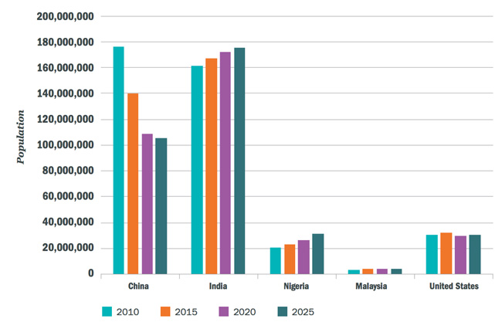
College-aged populations, actual and forecast, in selected sending markets, 2010–2025. Source: Universities UK, World Bank

As the Universities UK report puts it, “Projected demographic trends indicate that the UK may face an increasingly challenging environment in recruiting students from some overseas countries on which the sector has relied in the past.”

On a brighter note, the chart also highlights continued growth in this key college-aged cohort in other major growth markets, especially in India. Along with China, India has been the primary driver of overall enrolment growth in many study destinations and has certainly come to play a greater role in driving global mobility trends within the past decade.

Even so, the implications for recruiters is clear: competition for Chinese students is likely to intensify going forward and many programs will have to more actively build student numbers outside of China in order to continue to hit their enrolment targets.

Mapping the trends that will shape international student mobility 18 Jul 2017

Short on time? Here are the highlights:
- A new report reviews ten trends that are expected to have a significant effect on global demand for higher education
- Among the major factors projected to shape international mobility in the decades ahead: changing demographics and, in particular, shrinking populations of college-aged students as well as the increasing competition for market share among both established and emerging study destinations

A new British Council report sets out the key trends that are shaping both higher education demand and international student mobility. “We are at a tipping point in the global higher education system.

Students have more choices than ever,” says the British Council’s Director Education Rebecca Hughes. “Beyond and behind traditional student recruitment lie drivers of change that are shifting the very nature of how we view and deliver higher education: they are indicative of a larger movement in the education sector, in line with an uncertain and rapidly changing future.”

The full report, 10 trends: Transformative changes in higher education outlines the ten global trends that the authors have judged will have the greatest impact on higher education in the future.

These include some major shifts in demographics around the world. The British Council highlights in particular the influence of ageing populations in many regions. Simply put: greater life expectancy combined with lower fertility rates means that populations in many countries are getting older, and, in the process, the key 15-to-24-year-old college-aged cohorts are shrinking.

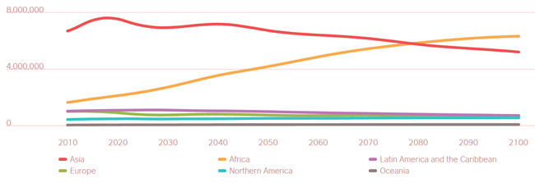
Youth population projections by global region, 2010–2100. Source: United Nations, British Council

That key college-aged demographic will peak in Asia somewhere around 2020 and begin a gradual decline from that high point through over the rest of this century. Only Africa will buck this trend, with its college-aged population projected to grow strongly for decades to come.

In fact, British Council forecasts project that five of the top ten fastest-growing 18-to-22-year-old populations through 2025 will be in Africa, and that the continent’s youth population will surpass that of Asia somewhere around 2080. “While demographics are only a small determinant of higher education mobility and enrolment, such stark trends are incontrovertible evidence of opportunities for engagement with students and youth in Africa,” notes the report.

Putting a priority on recruitment

The British Council also highlights the growing prominence of national strategies for international education, among both established and emerging study destinations.

Increasingly, these plans are focused on increasing the country’s market share in terms of internationally mobile students. They are also often closely integrated with broader national strategies for trade and economic development, including, for example, programs to promote skilled migration and close domestic labor market gaps.

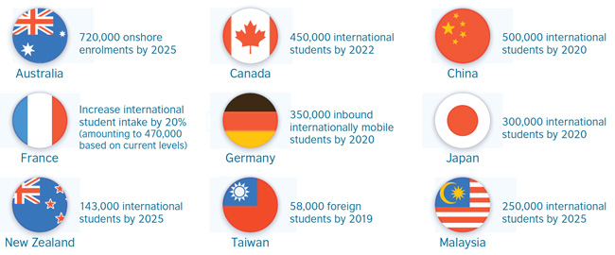
Selected international recruitment targets, as expressed in the national strategies of study destinations. Source: British Council

Weakening brand influence?

There is a great deal more to be said on this subject, but the report raises the question as to whether elite institutional brands will have less influence on student choice in the future.

Really, the observation that is being made here is that students and families appear to be placing more emphasis on value and, in particular, on the return on investment of an overseas education. At the same time, there are growing indications that major employers are placing less emphasis on educational brands – for example, via greater openness to non-degree credentials or by adopting so-called “blind” hiring processes that exclude school-specific information.

We have seen other indicators of this in recent research that points to a greater emphasis on subject-level rankings and career outcomes, and, even more broadly, to the importance of unbranded search in the student decision-making process. It appears too in the price sensitivity exhibited by some students that, while drawn to elite brands or leading study destinations, are also clearly open to other choices.

The lingua franca

The 10 trends report points out that English has become an important lever for international student mobility. This is reflected in global demand for English language learning, but also in the rapidly expanding field of English-taught degree programs in non-native-English-speaking destinations. The report adds: “English language provision also plays an important role in mobility, as the language acts as a draw for international students. Further, the language can be a pathway for future mobility as well, as students studying English in a host country tend to return to that country when pursuing overseas study.”

But questions abound as to how this pattern will continue to play out. How will institutions and educators adapt over the long term to the linguistic and pedagogical challenges of teaching in a language other than their native language? And what role will technology play, particularly with regard to online learning and the rapidly improving systems and tools for both language learning and near-simultaneous translation?

It is hard to imagine a future where English does not continue to play a major role in international mobility, but the authors leave room for this possibility as well: “As attention towards digital literacy increases, there is potential for English language literacy and programs to take a backseat as a new lingua franca emerges.”

Four megatrends that are changing the competitive landscape of international education 1 Nov 2016
Short on time? Here are the highlights:
- Every now and then it’s helpful to take a step back and consider the “big picture” elements that are shaping international student recruitment markets
- Here is a quick summary of four key trends that we are watching closely

Slowing growth, a booming middle class, shifting destination market share, and new regional study destinations are helping to set a new competitive dynamic in international education.

1. Slower growth, new destinations

Roughly five million students are studying abroad today – an increase of nearly 67% since 2005 – and the OECD projects that eight million students will be studying abroad by 2025. The big question is, what happens to the growth curve after that?

A major driver of student mobility to date has been unmet demand for higher education in developing countries: when students can’t access quality education at home, they become motivated to go abroad. This trend has spurred astonishing growth in the numbers of Chinese and Indian students that travel overseas to study over the past decade.

But the relative popularity of destinations is changing all the time. Asian higher education systems are steadily strengthening, to the point where several universities in China, Hong Kong, Singapore, and Malaysia now rank among the world’s best. A growing number of students in these countries are choosing to stay within the region to study, and students from other countries – including African ones – are adding Asian destinations to their list of attractive options.

As Asia increases its capacity to absorb students from the region and expands its recruitment of international students, countries such as the US, the UK, Australia, Canada, and New Zealand may well see demand for places in their institutions slow, especially from major sending markets such as China and India.

TAKEAWAY: Pursuing greater diversification in international enrolments will become ever more important for institutions outside of Asia. This is underlined not only by Asian institutions’ climb up the rankings, but also by the fact that the number of Chinese university-aged students will be notably smaller 15 years from now: demographers expect China’s population of 20-24-year-olds to decline by 20% from 2010 to 2020.

2. Middle class rising

Countries with expanding middle classes will see more of their students able to consider study abroad. In Asia, the middle class is expected to grow from 600 million in 2010 to more than 3 billion in 2030 to represent 66% of the total global middle-class population.

World Education News and Reviews (WENR) notes that “Upper-middle-income economies … are the ones driving growth in outbound student mobility. The total number of outbound international students from upper-middle-income economies jumped 161% between 2000 and 2012, as compared to only 29% from high-income OECD countries.”

TAKEAWAY: Some of the most significant emerging markets for international education are characterized by large and growing middle class populations. These markets include India (which may be the world’s largest middle-class consumer market by 2030), Nigeria, and Indonesia.

3. Leading destinations losing ground

At the same time as developing markets have been increasing educational capacity and quality, the heavyweights of international education – the US and the UK – have been losing market share. The US share of internationally mobile students dropped from 23% in 2000 to 16% in 2012, even as the absolute number of foreign students in America continues to climb. The UK has lost ground as well.

This shift is largely a function of increasing competition among destinations. Both Canada and Australia have attracted a greater share of international students over the past decade; other countries have also gained ground. The OECD reports that “significant numbers of foreign students were enrolled in the Russian Federation (4% market share in 2012), Japan (3%), Austria (2%), Italy (2%), New Zealand (2%), and Spain (2%).” As mentioned, Asian regional hubs are also beginning to capture the attention of prospective international students.

TAKEAWAY: The stage is set for a new level of competition among leading study
destinations over the next decade and beyond. National visa and immigration policies (including work rights for international students), coordinated destination marketing campaigns, scholarship programs, and intelligent strategies for the packaging of programs and study pathways will be some of the factors countries may be able to leverage as they attempt to maintain or increase market share.

4. New competition and regional hubs

The increasing role of intra-regional mobility is clearly visible in UNESCO statistics indicating that the percentage of Latin American students remaining within the region increased from 11% in 1999 to 23% in 2007. Similarly, the percentage of mobile East Asian students studying within the region rose from 36% to 42% over the same period.

Regional mobility schemes around the world have spurred such patterns. These include the ASEAN International Mobility for Students (AIMS) program and the landmark Erasmus program in Europe.

In addition, bilateral mobility arrangements, including Mexico’s Proyecta 100,000 initiative and the corresponding 100,000 Strong in the Americas program for students in the Western Hemisphere, are playing an ever-larger role in determining where students choose to study abroad.

Finally, certain Asian economies are busy developing their own centers of expertise and actively recruiting international students to them. Recent examples include the Philippines’ English-language Training (ELT) sector and the 10,000 new seats opened for foreign students at India’s premier engineering institutes.

TAKEAWAY: Students have an expanding array of educational options that are (a) close to home and (b) more affordable than those in traditional leading destinations such as the US and UK. To remain compelling, schools and governments in Western destinations will have to think hard about their points of competitive differentiation and will likely need to position themselves on benefits other than proximity and price. Bilateral agreements, quality, industry linkages including internships, and post-graduation work rights are some of the variables that will likely figure more prominently in these strategies going forward.

Global economic power projected to shift to Asia and emerging economies by 2050 6 Mar 2015

The professional services firm PricewaterhouseCoopers (PwC) has produced a series of megatrends reports that analyze high-level trends expected to shape the global economic landscape in the decades ahead. The latest in the series, The World in 2050: Will the shift in global economic power continue?, describes a dramatic shift in global economic power away from advanced economies and toward Asia and a block of faster-growing emerging economies.

PwC’s forecasting models project the world economy will grow at slightly more than 3% per year from 2014 to 2050, and that it will double in size by 2037 and almost triple by 2050. The report adds, however, that after 2020, they anticipate a slowdown in global growth. This is attributed to two main factors: a levelling off of the rate of expansion in China and some other major emerging economies, and a curbed rate of growth in the working age population in many large economies.

One of the most compelling findings in the PwC forecast is a projected shift in global economic power away from (currently) leading economies in North America, Western Europe, and Japan over the next 35 years.

The world in 2050, concludes the report, will be very different in terms of the global ranking of national economies and the major drivers of economic growth.

Size matters

PwC’s forecast model relies on projected trends in demographics, capital investment, education levels, and technological progress.

Its analysis compares national economies in two ways. Gross domestic product (GDP) measured via purchasing power parity (PPP) adjusts for differences in price levels across countries, whereas GDP in market exchange rate (MER) terms does not attempt to factor out such price differences from country to country.

“GDP at PPPs is a better indicator of average living standards or volumes of outputs or inputs, because it corrects for price differences across countries at different levels of development,” notes the report. “In general, price levels are significantly lower in emerging economies so looking at GDP at PPPs narrows the income gap with the advanced economies compared to using market exchange rates. However, GDP at MERs is a better measure of the relative size of the economies from a business perspective.”

The difference between the two is important in terms of providing a more nuanced understanding of relative economic growth and size. For example, China has already overtaken the US (as of 2014) to become the world’s largest economy in PPP terms, and is projected to surpass America in terms of MER GDP values by 2028.

Other notable projections include:
- India will be the second-largest economy in the world by 2050 (in PPP terms, that is, and third when measuring GDP via MERs).
- Emerging economies Mexico and Indonesia will be larger than the UK and France by 2030 (again, when measuring GDP in PPP terms).
- Nigeria and Vietnam are expected to be the fastest-growing large economies through 2050.

The following table shows the current global ranking of world economies as of 2014 and the projected rankings for 2030 and 2050, all in PPP terms. Keep in mind that today’s newborns will be in secondary school in 2030.
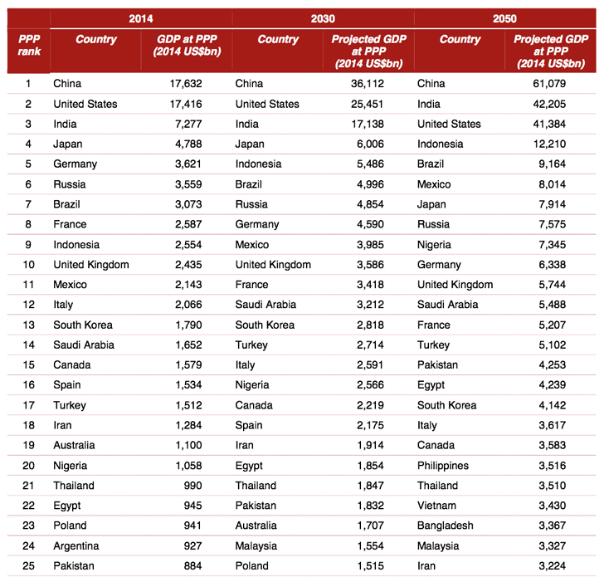
Global ranking of the world’s largest economies, GDP in PPP terms, through 2050. Source: PwC

The report highlights, “The rise of Indonesia and Nigeria through the world rankings throughout the period to 2050 is very striking. Indonesia rises from 9th in 2014 to 4th in 2050, and Nigeria rises from 20th in 2014 to 9th in 2050.”

The groups of seven

PwC also compares two key groups of countries: a modified “G7” grouping (Canada, France, Germany, Italy, Japan, the UK, and the US, plus Australia, South Korea and Spain) and the “E7” – that is, the seven-largest emerging market economies (Brazil, China, India, Indonesia, Mexico, Russia, and Turkey).

The following chart shows the projected growth trends for both the G7 and E7 groups through 2050.

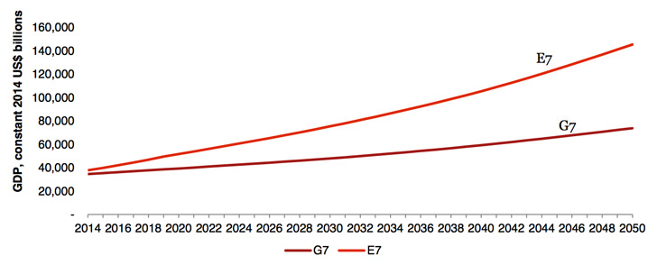
E7 and G7 growth paths in PPP terms through 2050. Source: PwC

As the chart illustrates, the E7 countries have already surpassed the G7 countries in terms of GDP adjusted for PPP exchange rates. When measured in MER terms, however, the G7 economies are still roughly 80% larger than the E7 group.

However, the E7 economies are also expected to overtake the G7 countries in MER terms by 2030. PwC adds, “Looking forward, our base case projections suggest that the GDP of the E7 countries will be around twice as high as that for the G7 countries by 2050 in PPP terms, and more than 50% higher in MER terms.”

Mind the gap

Another startling projection in the PwC forecast is that the gap between the three biggest economies – China, India, and the US – and the rest of the world will widen in the coming decades.

“In 2014, the third biggest economy in PPP terms (India) is around 50% larger than the fourth biggest economy (Japan). In 2050, the third biggest economy in PPP terms (the US) is projected to be approximately 240% larger than the fourth biggest economy (Indonesia).”

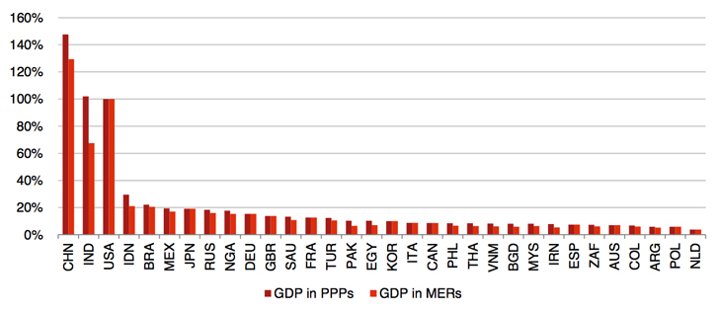
Relative GDP at MERs and PPPs in 2050 (% of US levels). Source: PwC

Also of note, the average income per capita (that is, GDP per capita) is expected to still be quite a bit higher in advanced economies in 2050. “The current gap in income per capita between developing and developed countries is just too large to bridge fully over this period,” says PwC.

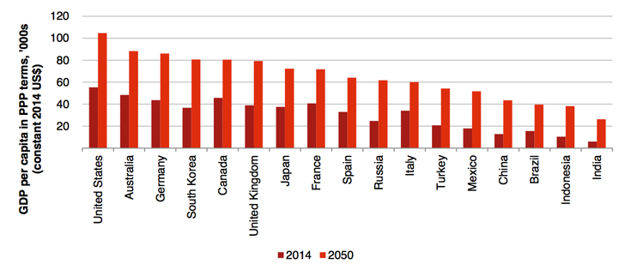
GDP per capita in PPP terms for the G7 and E7 economies, 2014 and 2050. Source: PwC

Bringing forecasts down to earth

The type of “megatrends” forecast that PwC offers in its report is useful for just that: a consideration of high-level trends that point towards major shifts in the world economy. And the major shift in question here is a transfer of economic power from advanced to emerging economies. On this point, PwC concludes, “Given the rise of India and China, our model suggests that the US and the EU’s share of world GDP in PPP terms will face a steady decline from around 33% in 2014 to only around 25% by 2050. This shift of global economic power to Asia may occur somewhat more quickly or slowly than this, of course, but the general direction of change and the historic nature of this shift are clear.” The implications for individual trading partners or organizations are of course less clear. But what PwC is describing here is not merely a shift in the relative size of economies; it is a profound transfer of economic and political influence across the globe. Whereas today we talk about emerging education hubs in Asia and elsewhere, by 2050 we may be reflecting on a remarkably different landscape for international education as well.

