Handout for Action Science and Theory U Presentation (June 22, 2019)

Single Loop Learning
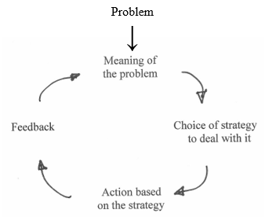

Model I Theory-in-Use (Argyris and Schon, 1974)

Governing  Variables | Action Strategies | Consequences for the Behavioral World | Consequences for Learning | Effectiveness
Define goals and try to achieve them | Design and manage the environment unilaterally | Actor seen as defensive, inconsistent, incongruent, competitive, controlling, fearful of being vulnerable, manipulative, withholding of feelings, overly concerned about self and others or underconcerned about others | Self-sealing | Decreased effectiveness
Maximize winning and minimize losing | Own and control the task (claim ownership of the task, be guardian of definition, and execution of task) | Defensive interpersonal and group relationship (dependence upon actor, little additivity, little helping of others) | Single loop learning
Minimize generating or expressing negative feelings | Unilaterally protect yourself (speak with inferred categories accompanied by little or no directly observable behavior, be blind to impact on others and to the incongruity between rhetoric and behavior, reduce incongruity by defensive actions such as blaming, stereotyping, suppressing feelings, or intellectualizing) | Defensive norms (mistrust, lack of risk taking, conformity, external commitment, emphasis on diplomacy, power centered competition, and rivalry) | Little testing of theories publicly. Much testing of theories privately.
Be rational | Unilaterally protect others from being hurt (withhold information, create rules to censor information and behavior, hold private meetings) | Little freedom of choice, internal commitment, or risk taking

Case Study with Derrah and Dave (page two as an example)
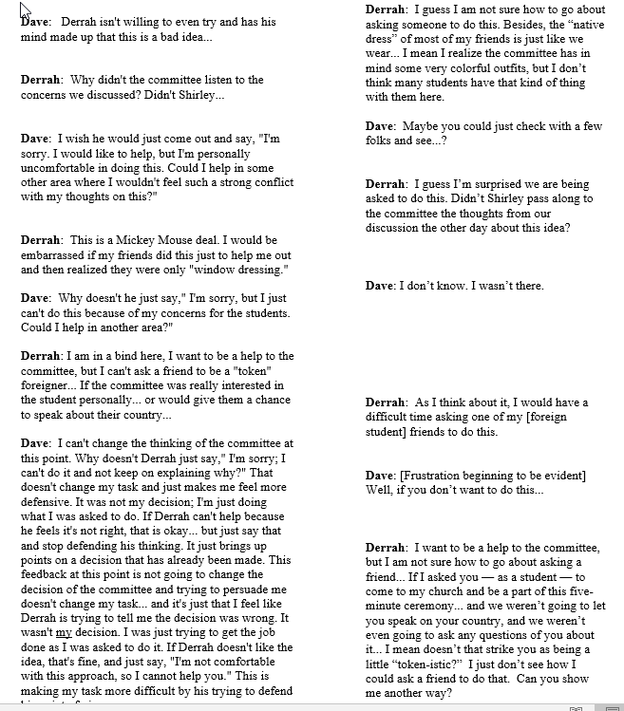

Double Loop Learning

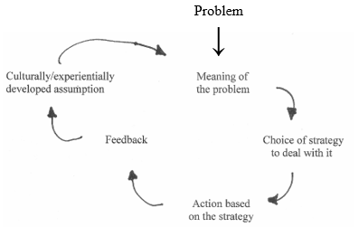

Theory U by Claus Otto Scharmer

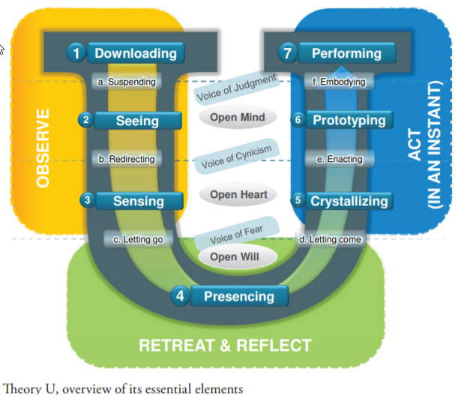

Adapted by Pastor David Whiteman from Theory U by Claus Otto Scharmer (9/15/2017)
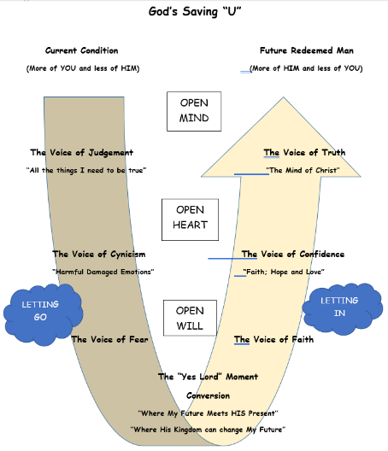

What is Action Science?
Action Science is a strategy for increasing the skills and confidence of individuals in groups to create any kind of organization (thus fostering long-term individual/group effectiveness). This strategy applies to any type of organizational or interpersonal context where individuals are engaged in doing challenging, difficult things together.
Basic Goal
The basic goal of action science is increasing professional effectiveness by helping individuals in small groups to shift from using Model I to using Model II in resolving difficult problems.
Problem Types
The action science model focuses primarily on identifying and resolving difficult, complex, real-life problems critical to organizations and society.
Theories of Action
Specific to action science is the Model I & II Theory of Action, a "meta-theory" or "theory about theories" (a hybrid technical and human theory of action).
Data Types
Action science asks whether data (knowledge or descriptive information) is actionable. This term is easiest to define by first outlining its opposite, non-actionable data.
Learning Defined
Learning occurs when individuals in groups detect and correct gaps between descriptive claims and practical outcomes (intentions and actual results, thoughts and actions, theories and practices) or produce what they claim to know.

Basic Goal of Action Science
Action science is a strategy for designing situations that foster effective stewardship in any type of organization. As a framework for learning the approach is designed to help individuals, groups, and organizations to develop a readiness to change to meet the needs of an often-changing environment.
To help individuals in groups to learn how to overcome barriers to organizational change, action science does not simply focus on improving the participants' problem-solving or decision-making skills. It also does not look only at making incremental changes (e.g., identifying opportunities; finding, correcting, reducing, or eliminating threats) in the external environment. Without eschewing these concerns, action science focuses on looking inward, learning new frameworks, and establishing new routines.
This website describes action science but to understand and practice action science is, well, not easy. The next step for this web site is to add real-world examples that demonstrate the use of action science.

Problem Types
A critical issue in action science is whether a problem is considered routine/trivial VS. non-routine/difficult. The difference is not always clear. Nevertheless, action science focuses on identifying and resolving the difficult, complex, real-life problems that are critical to organizations and society. This includes the formidable challenges of leadership, innovation, informed participation, and reducing prejudice. These bewildering problems often emerge and become more significant as group participants try to formulate and carry out new plans and evaluate their work together.

Model I & II Theories of Action
The main distinction in action science is between theories of action. Theories of action are the master programs, patterns, designs, sets of rules, or propositions that people use to design and carry out their actions. These are the governing variables, values, theories, beliefs, concepts, rules, attitudes, routines, policies, practices, norms, or skills that underlie actions.
There are two main types of theories of action. "Technical" theories of action are autonomous or distanced models of expert analysis. They include theories in micro-economic analysis, competitive strategy analysis, activity-based accounting, or rigorous quantitative empirical analysis. "Human" theories of action are theories about interpersonal relationships, effective leadership, administration, group dynamics, or organizational culture.
Action science represents a unique "Model I/Model II" theory of action, a "meta-theory" or "theory about theories," or a hybrid technical and human theory of action. Crafted to help increase professional effectiveness, it aims to help reduce individual and group ineffectiveness caused by defensive interpersonal and organizational relations by removing barriers to change. It helps reduce anti-productive defensive routines in real time, as group members carry out diverse types of technical and human action plans. Reducing ineffectiveness involves shifting from using Model I to using Model II in resolving difficult problems.

Model I Theory-in-Use

Governing Variables -
- Define goals and try to achieve them (unilaterally).
- Maximize winning and minimize losing.
- Minimize expressing or generating negative feelings.
- Be rational and minimize emotionality.

Action Strategies -
- Design, manage, and plan unilaterally.
- Own and control the task.
- Unilaterally protect self and others.
- Evaluate others in ways that do not encourage testing the validity of the evaluation.

Consequences -
- Defensiveness
- Mistrust
- COMPETITION
- Interpersonal manipulation
- Self-service
- Over-protective
- Conformity
- Use of power
- Low freedom of choice
- Low internal commitment
- Low risk taking.
- "Self-sealing, single-loop" learning
- Anti-learning
- Little public testing of notions about why others behave as they do, what they need, etc.
- Decreased effectiveness

Model II Theory-in-Use

Governing Variables -
- Maximize valid information.
- Have free and informed choice for all concerned.
- Have high internal commitment to the choice and constant monitoring of its implementation.

Action Strategies -
- Design situations where participants can originate actions and can experience high personal causation and success.
- Jointly control tasks.
- Make protection of self and others a joint enterprise.
- Craft positions or behaviors into action strategies that openly illustrate how the actors reached their evaluations or attributions, and how they crafted them to encourage inquiry and testing by others.

Consequences -
- Minimally defensive interpersonal relations
- COLLABORATION
- Cooperation
- Trust
- High individuality
- Open confrontation on difficult issues
- High freedom of choice.
- "Double-loop" learning (includes questioning of goals)
- Processes can be disconfirmed
- Public testing of theories and attributions.
- Increased quality of life
- Effective problem solving and decision making, especially for difficult issues
- Increased long-run effectiveness.

Model I
Model I involves single-loop learning processes: any practice that inhibits the participants from experiencing embarrassment or threat and prevents them from identifying, reducing, and correcting the causes of the embarrassment or threat.
Model I is the domain of anti-learning behavior. Model I actors do not encourage testing or validating claims, overprotect participants, and inhibit learning in detecting and correcting non-routine errors.
Single-loop learning and defensive reasoning processes produce mixed messages. They protect out of thoughtfulness, caring, diplomacy, or concern, as reality demands. However, in caring for and respecting others, criticism gets withheld. By avoiding conflict, the participants consistently fail to deal with difficult issues. As Model I processes do not activate theories-in-use, they reduce the possibility of learning.

The Basic Defensive Reasoning Pattern

Example I
- Recognize a mixed message
- Act like there is no mixed message
- Make this action undiscussable
- Make undiscussables undiscussable

Example II
- Recognize a mismatch between intentions and outcomes
- Bypass (or deny) the mismatch
- Cover up the bypass
- Cover up the cover-up
Defensive routines produce mixed messages at two levels:

Level I - Denial Routine
- recognize a mixed message, inconsistency, gap, or mismatch between intentions and outcomes
- act like it is not a mixed message or inconsistency, deny that defensive routines exist, bypass embarrassment and threat

Level II - Bypass Routine
- make this bypass action undiscussable (cover-up the bypass)
- make the undiscussable nature of bypasses undiscussable; cover up the cover-up

Example of Mixed-Message
A Mixed-Message, Outsider gets Invited to a Meeting:
I saw John today and he and Betty have set up a meeting for March. Um. It.. It's just a couple of us and this is the very, very, very first time we're ever going to be talking about the idea of a Web page for the group. You're welcome to come but you need to understand it's just at the very beginning stages and our thought was there would be another meeting where we could have... you know... bigger input with more people. But... the three of us... um... have been talking about this for a while and just want to get our thoughts together. So. Um... You're welcome to come but you need to understand sorta where we are with the process. Um... Give me a call if you got any questions.
Regarding the meeting, if this is the "very, very, very first time we're ever going to be talking about the idea of a Web page for the group," then how is it "the three of us... um... have been talking about this for a while ..."?
Is the intention here to help me understand the process? If so, why the mixed-message?

More on Model I
Excluded from this analysis are protective defensive routines that occur in response to some threatening environmental situation involving pathological or unjust acts. These defensive actions can be productive (e.g., if they do not inhibit learning) as they protect the actors from harm.
Defensive reasoning relies on the idea of deterministic causality, the claim that "A will cause B." This reasoning process fails to recognize the richness and uniqueness of concrete situations. Inevitable gaps, between stored knowledge and knowledge required to act effectively in new situations, go unrecognized. Therefore, the need to change the status quo, the present status of knowledge, gets overlooked. Not recognizing that any innovation is likely to be inadequate, the need to monitor the change gets bypassed.
With no monitoring, efforts to reliably repeat innovative actions are impossible. Specifying the action strategies or skills required to produce the desired consequences and the conditions necessary to maintain them is also impossible. Actions cannot be tested; solving problems cannot contribute to basic theory, for example, to ideas about how to achieve organizational effectiveness. At the heart of the matter, participants do not integrate theory and practice.
Model I is usually the "theory-in-use" by individuals, groups, intergroups, and organizations, with little variation in how it gets expressed.

Model II
Model II's main characteristic is double-loop learning, a productive reasoning process that involves minimal interpersonal defensiveness. Wide gaps exist between espoused theories and theories-in-use and action science is designed to help participants minimize these gaps.
Model II is the domain of usable knowledge. It has high standards for questioning goals and testing the validity of claims.
Productive reasoning relies on the idea of probabilistic causality, the claim that "A will probably cause B." Probabilistic causality allows for the richness and uniqueness of concrete situations. It recognizes the inherent gap that exists between stored knowledge and the knowledge required to act effectively, the continual need to change the status quo.
Participants who reason productively recognize that any innovation is likely to be inadequate and therefore needs monitoring. They reliably repeat effective actions, making outcomes of initiatives known publicly. They specify the action strategies and skills required to produce the desired consequences and the conditions necessary to maintain them. Action is testable, so problem-solving contributes to basic theory, theory gets integrated into practice.
What are some more of the characteristics of these effective groups? Effective groups resolve difficult problems by taking innovative action relatively soon. As the participants question each others underlying programs or the credibility of their ideas they maintain high levels of interpersonal openness. They accept that while openness is potentially or actually embarrassing, threatening, or frustrating, openness is necessary to increase trust and individuality in their group. Individual participants may deny the difficulties involved in carrying out their challenging plans but the members freely challenge, test, and correct the claims. By possessing high levels of action science skills, their minimally defensive interpersonal and group relations enable the group members to innovate and respond productively.
Model II is usually espoused but not practiced by individuals, groups, intergroups, and organizations, with a wide variation in how it gets expressed.
The central orientation in action science is therefore that on a nearly universal basis, in practically all cultures and across genders, a wide gap exists between espoused theory (Model II) and theory-in-use (Model I). Action science is designed to help participants minimize these gaps.

Data Types
Also critically important in action science is whether data, knowledge, or information is actionable. This difficult term is defined best by first outlining its opposite, non-actionable data.
What is data? Actionable and non-actionable data both consist of relatively directly observable conversations, or descriptions of actual or proposed problems. The problems involve issues of personal responsibility: where participants evaluate an event or attribute qualities to themselves or others. Observations include statements by the observer that outline their undiscussed thoughts and feelings, or internal monologues related to the descriptions. Action researchers may record these descriptions or conversations on tape as they engage in meetings with participants.

Descriptive Data:
With data that is not actionable, the descriptions of problems, or inferences drawn from observations, are difficult to understand or to accept as valid -- especially by people with contrary views. The premises underlying the observations are not explicit, so testing the validity of the claims using logic or data independent of those who make them, is impossible.
Non-actionable data develops out of pursuing applicable or useful research. It derives from descriptive research, inquiry that focuses on gaining insight or awareness, or on making discoveries. This descriptive research may alternately focus on understanding or developing a solution, proposal, idea, or policy.
By separating descriptive research from action research, useful descriptive data may provide explanations or contribute to developing basic theories. It does not, however, resolve difficult problems. Applicable descriptive data may provide advice but not the actionable knowledge required to overcome and change rigid defensive routines. In describing -- or claiming to resolve a problem -- descriptive data may increase its severity by bypassing the requirement to seek out and overcome its root causes.
Descriptive research does not require participants to specify what actions will produce the desired consequences -- like open confrontation on difficult issues. Missing is an outline of the appropriate behavioral specifications and skills required to produce the conditions necessary to maintain the predicted outcomes.
In action science, descriptive research is necessary but not sufficient for learning. It may induce harm as it remains within the status quo, failing to activate theories-in-use.

Beyond Descriptive Data:
Actionable descriptions, observations, or inferences can be understood, but not necessarily accepted, by individuals holding contrary views. The premises underlying the observations are explicit, so testing the validity of the claims using logic or data independent of those who make them, is possible.
Actionable data develops out of pursuing usable research. This involves combining descriptive research with normative research, inquiry that describes alternate possible frameworks, and prescriptive research, inquiry that informs participants how to get from the present framework to a better framework. Normative and prescriptive research efforts serve action. They help individuals and organizations to better detect and correct errors, create lasting solutions, and develop valid information. They become critical as participants go from describing their insights to formulating and carrying out an innovation -- and evaluating their work together.
Descriptive research in action science is not separate from efforts to resolve practical problems. Descriptions get tested by applying them to efforts to resolve practical problems. Descriptive claims about effective actions prompt changes in how participants craft their actions. Assessing the effectiveness of actions prompts modifications in descriptive claims. Equal concern goes toward advancing descriptive theoretical claims about the underlying basis of actions and to resolving everyday problems, to advancing practice.
The development of actionable knowledge requires that participants specify what strategies will produce desired consequences -- like high internal commitment, trust, and individuality. This fulfills the need to outline appropriate behaviors and skills required to produce the desired results and the contextual conditions necessary to sustain them.
Those who pursue actionable knowledge assume humans have a limited ability to process information. They accept that gaps always exist between stored knowledge and knowledge required to produce effective actions. To develop valid information therefore they engage in cooperation with others to close the gaps. The participants codify and reliably repeat effective actions so their requirements are not merely in their heads but known publicly. They continuously strive to change the status quo and activate theories-in-use.

Learning Defined
In action science, descriptive data is necessary but not sufficient for learning. Learning occurs when participants detect and correct gaps between descriptive claims and practical outcomes (intentions and results, thoughts and actions, theories and practices); produce what they claim to know. Action science calls this "reducing gaps between espoused theories and theories-in-use." Narrowing these gaps involves increasing rigor by testing the inferences participants make in reasoning about problems.
What is reasoning? Reason forms the basis of opinions, beliefs, attitudes, feelings, or actions in that it explains or accounts for the related facts. Participants reason as they advocate a position or reach conclusions about events. Reasoning occurs when attributing causes to actions or when evaluating oneself or others.
Inferences can be rated on a "ladder of inference."

Ladder of Inference

Maximum Inference
Rung 4 - Evaluate an Action -
"The action was effective (or not effective)."
Rung 3 - Impose Meanings on Actions -
"The intention the person had in taking the action was to...."
Rung 2 - Impose Meanings on Conversation -
"The meaning of the conversation is...."
Rung 1 - Experience Some Relatively Directly Observable Data -
Listen to a recorded conversation, not merely to what he, she, or they recall was said.

Minimum Inference
At high levels of inference someone states an attribution or evaluation like "the action was not effective." A level lower, at Rung Three, meanings are imposed on actions or causes are attributed to them. For example, "In taking the action, his intention was to..." At Rung Two inferences are made about the meanings embedded in a conversation: "When Terry said she was disappointed that the event occurred, she meant the following." At Rung One participants experience some relatively directly observable data, such as a conversation. They may listen to a recorded conversation instead of what someone reports was said in a conversation.
By testing, participants can infer their theory-in-use. They can ask, "Are the attributions we make at high levels of inference (Rungs Four and Three) rigorously connected to some relatively directly observable data (Rung One)? If not, they may infer their theory-in-use does not involve testing the validity of claims against what actually occurs.

Notes
Model II is not the opposite of Model I.

Opposite of Model I Theory-in-Use

Governing Variables -
- Decide unilaterally to not define goals and to not try to achieve them.
- Minimize winning and maximize losing.
- Maximize expressing or generating negative feelings.
- Be irrational and maximize emotionality.

Action Strategies -
- Design, manage, and plan unilaterally.
- Own and control the task.
- Unilaterally harm self and others.
- Evaluate others in ways that do not encourage testing the validity of the evaluation.

Consequences -
- Negativism
- Withdrawal
- Defensiveness
- Mistrust
- COMPETITION
- Interpersonal manipulation
- Self-service
- Over-protective
- Conformity
- Use of power
- Low freedom of choice
- Low internal commitment
- Low risk taking
- "Self-sealing, single-loop" learning
- Anti-learning
- Little public testing of notions about why others behave as they do, what they need, etc.
- Decreased effectiveness.
Last Update: July 30, 2000. Action Science Network.
Please E-Mail your ideas or comments.
Action Science Network (actnet@pobox.com)
Copyright © 1996-1999. Enhanced Designs. All rights reserved.

