Action Science and Theory U Presentation to ISI Leaders June 22, 2019

- We are always learning… mostly by trial and error… or what’s called experiential learning
- Through this we become quite efficient in dealing with the issues we face regularly
- The process looks something like this:

Problem
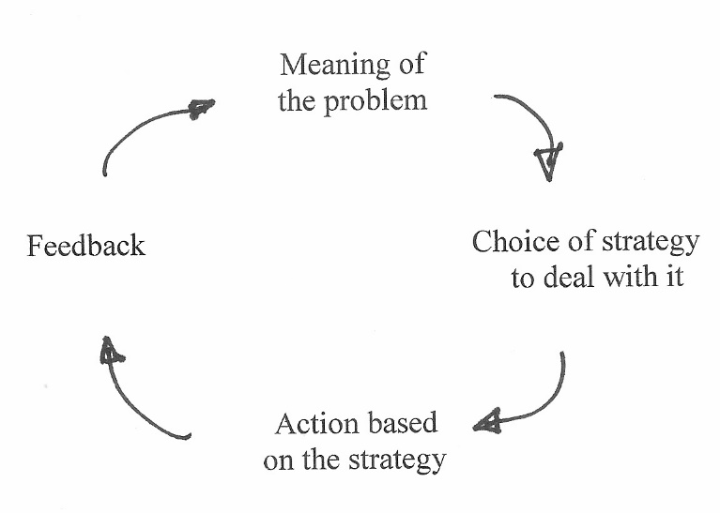
↓

- Management guru Chris Argyris called this single loop learning; it makes us quite efficient
- But sometimes things happen which we don’t expect, aren’t prepared for, or a conflict happens which catches us off-guard
- When I was new on ISI staff and working as part of a team in Austin, Texas such an event happened to me
- It was my privilege to be working with my long-time friend, prayer partner, and fellow elder at the same church named Dave (he was the city director and I was the new guy)
- The mission pastor at our church asked Dave to get some int’l students to carry their country’s flag at the start of a missions conference worship service at our church; this was not an insignificant request since that church supported each of us to the tune of 25% of our financial support; so, it could have been understood as “more” than a request… and Dave asked me to help recruit students
- I had a problem with the request since there was no plan to use the students in any way other than a symbolic or token gesture and it involved inviting them to a worship service where they would be classed as unbelievers needing the gospel (it was a missions conference!)
- In the phone conversation, I danced around the issue giving all kinds of reasons I did not want to do what he was asking… other than just stating why I thought the idea stunk (because I knew he already had his mind made up and I would make him angry)
- He interpreted my resistance as not following his leadership… and the call did not end well
- At that time Abel and I were studying a leadership-management-consulting technology called Action Science where we would work personal cases weekly; the process usually took about an hour; so, I wrote up the case of the phone call gone bad with Dave to work as a case
- The process required making out a sheet with two columns; on the right side of the page you wrote what was said and done, then on the left side what was thought but not said
- It looked something like this:
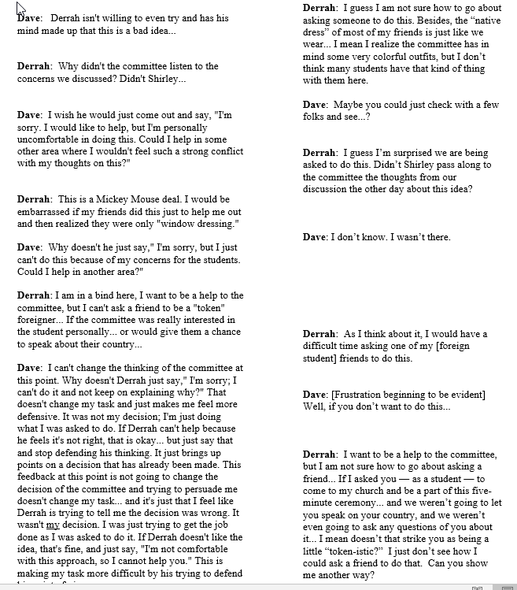

- After I did my part, I asked Dave to do his part; and the result was very accurate as to what took place that ended badly and left a problem in our relationship—me seeing him as insensitive to students and him seeing me as unhelpful and stubborn
- Dave and I met with several other students and our professor at the university to work the case; it was the first time the group had ever worked a case with both parties there
- I took the pagans about 10 minutes to discern that Dave and I could “not have a fight”; it was one of the fastest cases we had ever worked!!
- When asked by the group if we could have a fight we both responded “Sure”; and then they proceeded to show us from the data we provided that we could not have a fight… and that was why the phone call went off the tracks—WE COULD NOT SAY THE OBVIOUS to each other and thus danced all around the issue in ways that just made it worse!
- Both Dave and I were shocked to see (with the help of these well-meaning pagans) that while we SAID we could have a fight, we could not… after all we were both elders, we had been weekly prayer partners for 90 minutes each week for more than a decade, we were best friends, we supported each other’s ministry financially… so we could not risk telling each other the brutal truth about how we felt about each other’s actions… and ended up angry any way
- Dave and my response to the intervention by the pagans was to commit to being deeply and brutally honest with one another (in love) in our relationship from then on
- By the way, Dave and I are still best friends today—30 years later—and we still pray for one another and financially support one another’s ministry… and we are still committed to being brutally honest with one another in love! Oh, and I still resent that it only took 10 minutes for the pagans to figure out what Dave and I could not see for ourselves!
- Okay, let analyze what happen using Action Science…
- Dave and I had “espoused theories” of action that we could have a fight… after all that should be true of any adult; but we also had “theories of practice” (meaning what we actually believed and that governed our choices and behavior) that two mature elders and friends could not have a knock-down and drag-out fight—espoused theory vs. theory in practice
- The real problem here was that the subtle difference between the two theories of action was unknown to both of us… or we had psychologically chosen to ignore the difference because it had not caused a problem up until then… this is know as a “defensive routine”; it allows us to keep working our normally chosen solutions to problems that typically work for us even when it leads to the train going off the tracks
- You may be thinking “that’s crazy…” and it is… but we all do it (it turns out); welcome to being normal!
- Argyris and others at Harvard were able to model what was going on, and they called it Model I Theory-in-Use; see the chart for Model I

- [Read through and explain the Model I chart] Abel?
- You may be thinking at this point… “It can’t be as simple as this chart”; well it is
- After working more than 50 real-life cases, it always comes back to these four personal values that cause us trouble in our work, ministries, and life!
- Now with the help of the well-meaning and honest pagans, Dave and I had to slow down the action in our relationship/ministry together and reflect upon what was going on; and it made all the difference in the world… allowing us both to grow and become more effective in life
- Remember that process chart of handling a problem? Here is an addition to it:

Problem
↓

- Argyris and team called this double loop learning… meaning that one had to stop and look at the assumptions about life, people, action, and interactions that governed how we made sense of life and figured out how to make choices about actions to take
- Dave and I had to realize the difference in our espoused theory-of-action and our theory-in-practice about how to handle strong differences of opinion with each other
- Also we had to commit to a new set of governing values in our relationship… which made the relationship more mature and able to handle difficulties in the future (where we were able to work through problems together)
- Argyris and team called this Model II Theory-in-Use; see the chart
- [Read through and explain the Model II chart] Abel?
- Model II allows for tears, it allows for seeing blind spots, it allows for interdependence of team members, it allows for better decisions of your team; it makes you make explicit your reasoning and assumptions about issues and allow for evaluation of those or reconsideration of them in order to make better decisions based on better data
- But Model II takes time… it slows down the action and efficiency… but it makes better decisions! What would have happened if Model II had been used regarding the invasion of Iraq? (actually, Bush did seek disconfirming data to prevailing assumptions and was provided none by analysts)
- Model II makes us slow down the process of decision making and make sure there is internal commitment of the entire team to the decisions being made; this allows for open evaluation and realistic discussion of results (good, bad, or indifferent results)
- Living in reality and searching out options is one of the most important tasks of the leader; taking time to ask difficult questions about what is being done, and evaluating results against expectations of stake-holders
- Someone has said the seven last words of the church are “We’ve never done it that way before”
- Is it just the leader’s responsibility to think these things through? Model II would suggest it is every vested person on the team’s responsibility! Now a team member’s piece of the picture may not be a large as the leader’s piece—they may be different in scope!
- As mentioned earlier this morning, having a team quietly listen to the Lord for a day or two and then discuss what they heard the Lord say is a very popular strategic planning process these days; I have heard of it being used in several mission organizations, campus ministries, churches, and Kingdom-oriented businesses lately
- That process of thinking deeply about every aspect of your current activities is the subject of an approach out of MIT lately called Theory U (for a shape of the process when graphed out)

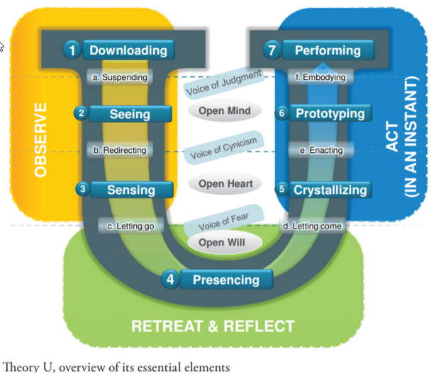

- The Theory U model actually built upon the work of Action Science, but helps us see in much more detail the process of thinking something through deeply; and as leaders, this is our responsibility—observe, retreat and reflect, then act
- A big part of the problem is how do we untie ourselves from the deeply held assumptions and theory-in-practice perspectives we hold and have learned experientially over years of ministry
- The answer is that it has to be intentional… and typically done by a group of peers in Model II fashion
- Theory U gets a little “new age” (“allowing our inner knowing to emerge”) but as a practical process can be very instructive for us… AND it allows for spiritual knowing as a part of the process (which we see as the Lord’s leadership of us)
- Let me read to you from some of their literature…

Leading from the Future as It Emerges

Building upon two decades of action research at MIT, Theory U shows how individuals, teams, organizations and large systems can build the essential leadership capacities needed to address the root causes of today’s social, environmental, and spiritual challenges. In essence, Theory U shows how to update the operating code in our societal systems through a shift in consciousness from ego-system to eco-system awareness.

Tapping Our Collective Capacities
We live in a time of massive institutional failure, in which we collectively create results that nobody wants. The list is well known: Climate change. Hunger. Poverty. Terrorism. Violence. Destruction of communities, nature, life—the foundations of our social, economic, ecological, and spiritual well-being. These times call for a new consciousness and a new collective leadership capacity to meet these challenges in a more conscious, intentional, and strategic way. The development of such a capacity would allow us to create a future of greater possibilities.

Illuminating the Blind Spot
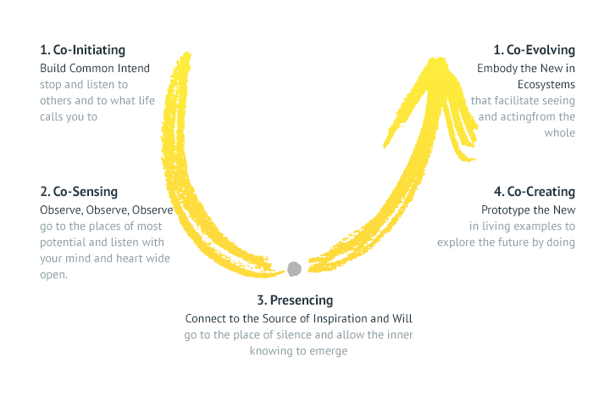
Why do our attempts to deal with the challenges of our time so often fail? Why are we stuck in so many destructive patterns today? The cause of our collective failure is that we are blind to the deeper dimension of leadership and transformational change. This “blind spot” exists not only in our collective leadership but also in our everyday social interactions. We are blind to the source dimension from which effective leadership and social action come into being. We know a great deal about what leaders do and how they do it. But we know very little about the inner place, the source from which they operate. And it is this source that Theory U attempts to explore.
- The foundational capacity of the U process is listening—listening to others, to self, to the Lord, and to what emerges from the collective. This requires the creation by the leader of open space where others can contribute to the whole and feel it is their responsibility to do so
- It is not easy to suspend the voice of judgment, but it is necessary to move from personal projection (of our biases and assumptions) to focused and peripheral observations. This also involves letting go of our egos—personal, team, and organizational. When this happens, fear is removed from the process along with personal defensiveness to ideas.
- Moving down the left side of the model requires the group to open up and to deal with the resistance of thought, emotion, and will.
- What they call presencing requires quietness and reflection in an unhurried atmosphere. That is why the Theory suggests it has to be done in a retreat setting. A personal observation is that there is a limit of the number of people who can be present at that setting—5-7 is optimal—but more makes the openness process more difficult. If you have more people, use multiple retreats with smaller teams (homogenous or diverse teams depending upon your purposes for the retreat).
- Through discussion of what the Lord and your inner person are saying, new paradigms and perspectives emerge.
- Moving up the right side of the model requires integration of thinking, feeling, and will in the context of practical applications and experiential learning by doing (with Model II governing values).
- Crystalizing is the part of the process where new vision and intention emerge; people coalesce around new perspectives, vision, and intention.
- Prototyping links head, heart, and hand (thinking, emotion, and will) into practical embodiment of action, approaches, and programs.
- Performing involves the action science principle of action, data gathering, and evaluation for the purpose of deciding about further action (or revision).
- Please realize that this process may lead to some changes you were not expecting. Goal changes, role changes of staff, personnel changes, and how finances are dedicated. These changes can be very disconcerting to existing staff, so that is why it is critical to have their involvement in and whole-hearted commitment in the process. Otherwise changes are resented by those not involved the change process.
- Hopefully this has stimulated your thinking about how to deal with intransigent problems you face and the occasional situation that goes off of the tracks and yields unexpected results that are problematic.
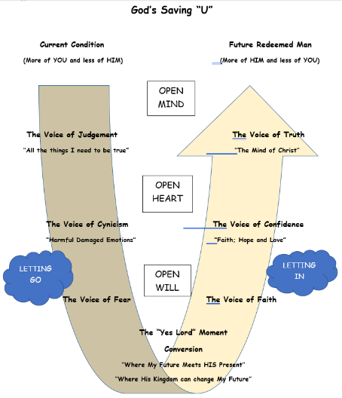
- The bottom line for us is to take time to let the Lord lead you and do everything in love (I Cor 16:14). The process is not one of mindlessness (as the new agers would assert), but even the pagans can help us see some of the steps which will mature us and lead to more effective results in our ministries… especially as leaders!
- Thanks!
- Invitation to Q&A
- [If time permits, “Here is what one pastor did with the Theory U model.”]

