Why is God Reviving 24/7 Prayer?
(Read the book Red Moon Rising.)

More than one million are involved in 24/7 Prayer. Should ISI be part of this growing movement of prayer?
Join 24/7 Prayer for ISM at our new ISI website: https://24-7prayer4ism.org/
View this key video about Beginning 24/7 Prayer in ISI: https://youtu.be/tYsGfP8PK6A
Watch this video on How to Do a 24-Hour Fast: https://youtu.be/qVRcIyjZ5fE
Why would God call people to pray to Him all day and all night?
- It takes a whole community of people working together in unity to make all-day and all-night prayer even possible. It helps to bind a community of believers as they seek God together in unceasing prayer.
- It seems that this kind of prayer is one way a community shows honor to God. The prayers and praises of the community rise continually to the Lord.
- If our God is always at work in our world, this might be His invitation for us to join Him with our 24/7 prayers for His Kingdom to come and His will to be done on earth as it is in heaven. As the disciples said, “Lord, teach us to pray.”
I was asked to preach a message on prayer for the Missions Conference at our home church in the DC area. Our very traditional church stepped up and did something they had never done before. They did a week of 24/7 Prayer that involved about 150 people. It had a profound impact on the church and its ministry.
How Can 24/7 Prayer Happen in ISI?
- Have an online Prayer Room
- Use Zoom as a way to pray together from anywhere in the world
- Have people sign up for one-hour timeslots of prayer
- Post prayer requests & Scriptures as a guide for our praying
- Keep the prayer room secure for use by those invited
- Invite our international friends and returnees to join us in prayer to help cover the late-night prayer times (since they are overseas)
- Invite Christian students to join in 24/7 Prayer
- Invite ISI donors, prayer supporters, and volunteers from all over the nation to join with ISI’s team as a community of 24/7 Prayer
- ISI’s first week of 24/7 Prayer resulted in 200 joining for about 400-500 hours of prayer.

What Is 40 Days of Prayer and Why Do It?
Drafted by Tim Sigman - January 2022
What is 40 Days of Prayer? ISI teams (campus, city, or regional teams) collaborate to develop an ISI 40 Days of Prayer calendar to launch fall and spring semesters in prayer. Each team member submits six key prayer requests to fill six weeks of the 40 Days of Prayer calendar. Each team member sends the calendar out to their prayer partners, usually by email, and asks them to join in praying for 40 days (see 40 Days of Prayer Calendar sample).
The team (may include key volunteers and Christian students) joins a 30-minute weekly Zoom Prayer Call (for six weeks) to pray with each other and celebrate answers to prayer. This 40 Days of Prayer model has brought more breakthroughs in our ISI ministry than any other prayer effort we have tried. My wife Julie and I have done 40 Days of Prayer with our teams for the past 12 years and nothing else has been as effective in mobilizing prayer and uniting our teams in concerted prayer for each other.
Reasons Why I Believe 40 Days of Prayer Has Proved So Effective:
1. It helps to mobilize a large number of people to pray together with a concerted focus.
2. It brings greater unity to the staff team as they pray and support each other in a weekly prayer call.
3. It is a declaration of our dependance on God as we start a new semester of ministry.
4. When team members see an answer to prayer, it is celebrated, and they grow in hope and faith.
5. Agreeing together in prayer in Jesus’ name is a very powerful way to pray.
6. Submitting six key prayer requests each semester helps team members clarify what they are seeking from God.
7. The model helps team members stay encouraged in prayer because they are doing it together in community.
8. Praying every day for 40 Days can begin to build stronger lifelong prayer habits.

Some Key Answers from 40 Days of Prayer:
1. Twice God moved out an anti-Christian Director of the ISO and replaced him or her with a believer in Christ.
2. New staff for Princeton was first requested for 40 Days and the call regarding interested staff came that week as we prayed.
3. Space for parking at the ICF at UMD was provided the same week we were praying—free space/parking across street from campus.
4. New York City had one staff member for many years, but after 40 Days Prayer, the team grew to 14.
5. In DC, there was one part-time staff member but after 40 Days of Prayer, that team grew to 6 staff members with three more applying to join.
6. We prayed for the opening of new ISI ministries and the following added after 40 Days of Prayer: Johns Hopkins, University of Delaware, George Mason University, University of Maryland Baltimore County, Montgomery College, Pace University (NYC), and St. John’s University (Queens NY).

40 Days of Prayer Guidelines
- Decide with your team a date to start praying several weeks or more before the semester begins.
- Send out the calendar over a shared Google doc, if possible, so each person can fill in their weekly prayer requests.
- Make your requests specific and brief.
- Pick a day and time that the team will meet online each week for 30 minutes.
- Create a Zoom link (or Google meet, etc.) for the 6 weeks.
- Designate one person to be the host of the event who will do the following:
  - The host sends out a weekly reminder the day prior to the meeting with the meeting link and an attached prayer calendar.
  - The host picks a Scripture verse (or hymn, or poem, etc.) to read at the beginning. Something to inspire worship, motivate to service, or however the Spirit leads. This can also be given to another member to do or to a new person each week.
  - The host opens the Zoom call several minutes early.
  - The host greets all attendees and begins promptly at 2-3 minutes after the start time.
  - The host (or the designated person) reads the Scripture and shares why he/she picked it, if desired. This should take no more than 5 minutes.
  - Make sure everyone has a copy of the calendar. If needed, the host can share screen and post it.
  - Begin the prayer by stating, “Let us pray.” The host can pray to start or remain still and allow others to begin.
  - The host will keep an eye on the clock and make sure to close the prayer time within a minute or two of the end time.
- The first few minutes of prayer are spent in worship. This can reflect the verse that was read, praises for things that have happened over the past week, or something the Lord has put on people’s hearts.
- After some praise time, move into the requests for that week listed on the calendar. The goal is that everyone will take a turn to pray for 1-2 requests, leaving enough requests so others have something to pray about and making sure that none of the requests are missed. Some people prefer to assign each request to a person for prayer. Others prefer to allow free flowing prayer, with the host making sure all requests are covered at the end.
- As participants pray, they can also include issues that have come up for their campus that are not on the calendar.
- End promptly on the half hour, so people know this is a focused time of prayer and not a social time to chat. Obviously, if people want to stay on the call to talk further, that is up to the host.

How to Collect Prayer Requests from Your Team
to Create a 40 Days of Prayer Calendar

A simple form is helpful to collect the 40 Days of Prayer team prayer requests. Each member enters his/her own requests, which will then be populated into an Excel spreadsheet.
https://forms.gle/jeACA2xhAmSJtYVP7

Here are how the responses are collected and what the spreadsheet looks like:
https://docs.google.com/spreadsheets/d/1F4u2YPUfDrtUYxBv6EvOyex6STXgdcmnMPX-BTFO1_M/edit?usp=sharing

Use Text Wrapping feature (see image below) to show full prayer requests you have entered.

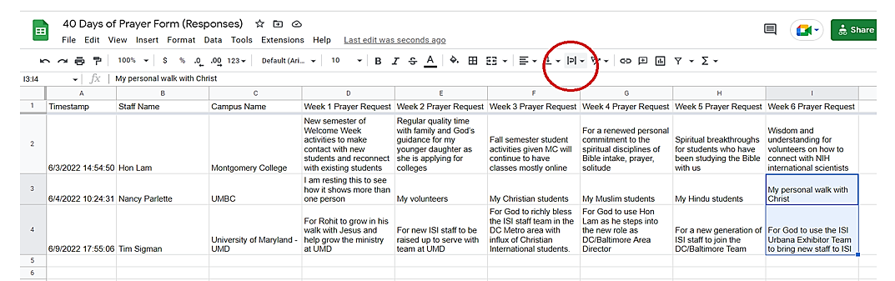
Print out Excel spreadsheet as PDF for a paper copy of the calendar that looks like the image below.
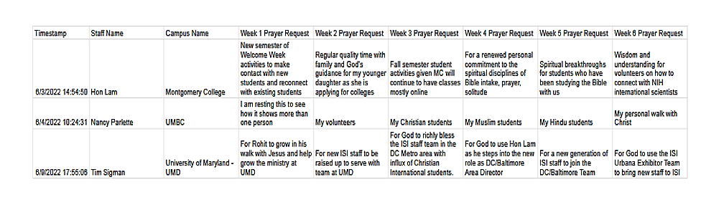If you have tech questions, please contact Hon Lam at hlam@isionline.org.
What Is Prayer Walking and Why Do It?

1. Focused Prayer While Walking at a Specific Area or Location
Genesis 13:17 says, “Go, walk through the length and breadth of the land, for I am giving it to you.”

Matthew 6:10 says, “Your kingdom come. Your will be done, on earth as it is in heaven.”

As we prayer walk, we are claiming the land like Abraham did when he walked through the length and breadth of the Promised Land. We are praying on a campus (or in a community) asking God’s Kingdom to come and His will to be done on earth in this location.

2. Prayer Walking is Praying Onsite to Gain Insight
As we prayer walk onsite at a specific campus or location, God can open our eyes and give us insight about how to pray for that area. We can also pray over people we see on the prayer walk.

Romans 8:26 says, “In the same way the Spirit also helps our weakness; for we do not know how to pray as we should…”

3. Prayer Walking Allows Us to Pray in Agreement and Conversationally with a Partner
Matthew 18:20 says, “For where two or three have gathered together in My name, I am there in their midst.”

When we prayer walk with another person, we can pray in agreement in the name of Jesus. He is in our midst. We can pray out loud going back and forth in a conversational approach to prayer much like walking together with a friend and having a conversation.

4. Through Prayer Walking We May Encounter Divine Appointments
Philip and the Ethiopian eunuch met while Philip was walking on the road from Jerusalem to Gaza. God had a “divine appointment” for Philip.

Acts 8:26-27 says, “But an angel of the Lord spoke to Philip saying, “Get up and go south to the road that descends from Jerusalem to Gaza.” (This is a desert road.) So, he got up and went; and there was an Ethiopian eunuch, a court official of Candace, queen of the Ethiopians, who was in charge of all her treasure; and he had come to Jerusalem to worship.”

5. Praying for the Welfare of the City or Campus – Start Semesters with Team Campus Prayer Walk
Jeremiah 29:7 says, “Seek the welfare (blessing) of the city where I have sent you into exile and pray to the Lord on its behalf; for in its welfare, you will have welfare.”

Prayer walking can bring the blessing of God on campus.

6. Consider Daily Prayer Walking to Build a Habit of Prayer and Better Health
My wife and I started daily prayer walking about 12 years ago. It has radically grown our prayer life, blessed our marriage, helped us to get daily exercise, and gave us better mental health as we dealt with all the stress of COVID. We got fresh air each day and were richly blessed as we prayer walked in the beauty of creation.

