Setting Widgets on Virtuous Dashboard
Step 1 – Click on “Add a widget”

Step 2 – Select “Recent Gifts” from the drop-down menu, then click “Save Dashboard Widget.” (This widget will list gifts to all projects you are the owner of.
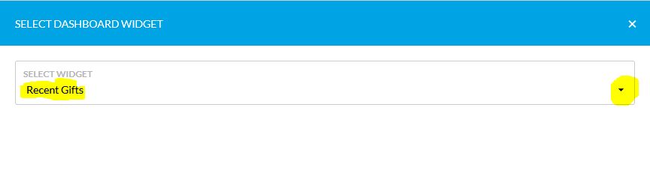

Step 3 – Once your Recent Gifts widget is set, click the next box to “Add a Widget.” (Do not hit the back button on your browser.)

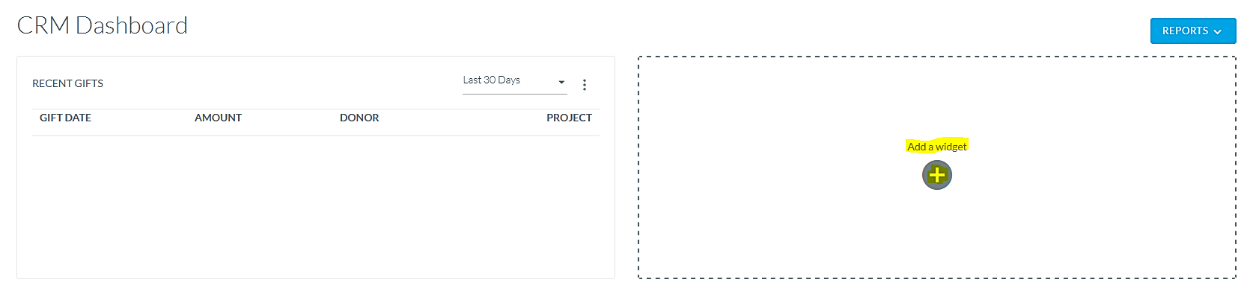

Step 4 – Select “Project Goal Overview” from the drop-down menu, then scroll down to “Save Dashboard Widget.”

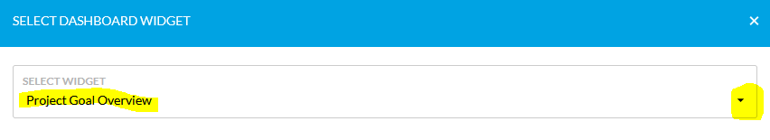

Step 5 – Select the project for your “Project Goal Overview” widget.

These are the most helpful widgets available within Virtuous, but you are welcome to continue to add additional widgets to your own personal dashboard. Please note, some features and reporting do not provide desired results based on permission settings. This is to ensure data privacy as it relates to your specific donors and donations.

